

Management
Report

1Q25

Management Report | 1Q25

Dear reader,
In 1Q25, we recorded net income of R$6.8 billion with R$16.8 billion in value added to society, considering taxes, salaries, dividends and other components.
We highlight that this was the first result to include the changes brought about by CMN Resolution 4,966/2021, which introduced structural changes in the accounting of financial assets and the measurement of expected losses. The new approach, aligned with international standards, improves transparency in risk management, directly affecting the establishment of provisions and the classification of financial instruments.
When we talk about the main business, which is credit, the credit portfolio exceeded R$1.2 trillion, growing in all segments in which we operate in the annual comparison.
In the individual portfolio, the highlight was the payroll loan operations, which reached R$335.7 billion. The new private payroll loan launched recently exceed R$3.0 billion. In this product, we will take a leading role and will apply our historical expertise to make our business more sustainable.
In the corporate portfolio, both MSMEs and large companies and the government segment showed growth compared to the same period of the previous year, demonstrating our commitment to these markets.
In agribusiness, we highlight the positive performance of the expanded credit portfolio, which grew by 9.0% compared to the same period of the previous year.

In the nine months of the 2024/2025 Harvest Plan (July to March/24), R$152.5 billion in credit was disbursed to agribusiness, in addition to R$22.2 billion allocated to the sector's value chain. Thus, overall, the total amount disbursed in credit and the value chain reached R$174.5 billion, compared to the R$179.4 billion recorded in the same period of the previous harvest.
More than 488 thousand operations were contracted, covering more than five thousand municipalities throughout the country. Of the resources released, 64.4% were directed to family farming (Pronaf) and medium-sized producers (Pronamp).
For the 11th consecutive quarter, we maintained our best position in the Central Bank Complaints Ranking among the five main banks with digital and physical operations, remaining in 14th place on the list of 15 institutions with the largest customer bases.
Recognized for the 6th time as the most sustainable bank on the planet by the ranking of the 100 Most Sustainable Corporations in the World 2025 – Global 100, by Corporate Knights.
We remain committed to building a Banco do Brasil that delights customers, offering a close relationship and an integrated phygital experience.
We invite you to learn more about our results on the following pages.
Good reading!

Consolidated Results
In January/25, CVM Resolution 4,966/2021 came into effect, which provides, among other topics, on the accounting concepts and criteria applicable to financial instruments, and whose initial adoption impact is detailed in Explanatory Note 2.
CMN Resolution 4,966 was applied prospectively, therefore, for the income items presented in the 1Q25 Financial Statements there will be no comparative table with previous periods.
Total assets reached R$2.4 trillion, while customer funds totaled R$865.0 billion. The Basel Ratio was 14.14% and the Core Capital Ratio was 10.97%.
For more details on the income and equity items for the period, please see the Explanatory Notes to the Financial Statements and the Performance Analysis Report.

Net income of R$6.8 billion

Credit Portfolio
R$1.2 trillion

 | Banco do Brasil | BB Consolidated
Earnings (R$ million) | 1Q25 | 1Q25
Net Income | 6,799 | 6,772
Income from Financial Intermediation | 11,335 | 13,118
Provision for losses associated with credit risk | (11,276) | (11,487)
Fee Income | 4,658 | 8,361
Administrative and Personnel Expenses | (9,457) | (9,954)
Equity (R$ million)
Assets | 2,379,656 | 2,420,992
Classified Loan Portfolio | 1,201,599 | 1,223,818
Resources from Customers | 825,992 | 864,972
Shareholders Equity | 174,643 | 184,189

Shareholders
We have a base of 1.5 million shareholders, 99.0% of whom are local individuals. At the end of March, our shareholding structure was distributed as follows: 50% of shares held by the Federal Government, 49.6% in free float and 0.4% in treasury. Local investors held 76.7% of the shares, and foreign investors held 23.3%. Our shares (BBAS3) represented 3.813% of the Ibovespa in the last four months.
The total amount allocated to shareholders in 1Q25 was R$2.8 billion and the value per share was R$0.48.

Strategy and Governance Corporate

The Corporate Strategy (ECBB) is the document
that reflects the essence of our company. It is our why as an organization. It involves defining priorities, clear goals, allocating resources and making strategic decisions that will help us generate more sustainable results and value for society as a whole.
The ECBB has a five-year time horizon and is reviewed every year through a structured, participatory process using consolidated methodologies, was approved in December 2024.
In this cycle, we ratified our purpose and values, reaffirming our commitment to supporting our customers and partners at all times. And we maintained our focus on our long-term objectives, which guide our actions focused on customer
experience, social and environmental
responsibility,
innovation.
digital
transformation and

Our governance structure is composed of the General Shareholders' Meeting; the Board of Directors (CA) and its advisory committees – Audit Committee (Coaud); Personnel, Compensation and Eligibility Committee (Corem); Risk and Capital
Committee (Coris), Technology and Innovation Committee (Cotei) and Corporate Sustainability Committee (Cosem); the Executive Board, composed of the Board of Directors (President and Vice-Presidents) and other Directors; and the Fiscal Council.
The Board of Directors has at least 30% independent members, in accordance with the provisions of the Bylaws, legislation and the B3 Novo Mercado Regulation.
In 1Q25, the Board of Directors approved the unified model of the Annual Charter of Public Policies and Corporate Governance for the Prudential Conglomerate (CPBB). The model will include the Related Entities headquartered in Brazil, which make up the CPBB, and which express their adherence to the unified Annual Charter.
The Annual Charter of Public Policies and Corporate Governance can be found on Banco do Brasil's Investor Relations Portal or at
https://ri.bb.com.br/en/corporate-governance-and- sustainability/annual-chart-of-public-policies-and-corporate- governance/

Clients

BB places the customer at the center of its strategy, seeking to build a lasting relationship that is relevant in the customer's life at all times. Its value proposition is materialized by offering hyper- personalized experiences, by the “Figital” strategy, which integrates the best of the physical and digital worlds, and by operating in the value chain.
In this context, the new CRM architecture has improved the service experience by integrating, in a single platform, resources such as telephone, email, chat and corporate WhatsApp, the latter being an unprecedented innovation in the market. The solution already reaches 17 thousand employees from different sectors, providing greater efficiency and connectivity.
As a result of this improvement, we have the modernization of URAs (Audible Response Units) that are advancing with the migration to the cloud. This transformation enhances data management and curation, in addition to introducing functionalities enabled by artificial intelligence (AI), raising the level of service offered.
Our onboarding process is constantly evolving, resulting in advances such as the simplicity of opening a university account, which is now 100% digital, in line with the strategy of rejuvenating our customer base.
We recorded a record 1.3 million new individual account holders, representing a 30% increase compared to the previous quarter. Another highlight was the 1.2 million customers aged between 0 and 17, of which 34% use BB Cash, with engagement exceeding 95%.
In the context of customer benefits, the automatic conversion of benefits generated R$26.6 million, representing a significant growth of 106%
compared to the same period last year and an increase of 16% compared to 4Q24.
In the High Income clients, we expanded our specialized advisory services to 150 thousand new clients, totaling more than 7.4 million clients in managed models. In the Private segment, we have the largest network of offices in the country, and we were awarded the Best Private Bank in the Country for sustainability by the Euromoney Private Banking Awards 2025.
For SME clients, the Painel PJ, a solution that supports the financial management of micro and small companies, had 216 thousand users in 1Q25 and managed annual gross revenues of over R$850 billion. In this segment, the BB Empresas Benefits Program reached the milestone of 1.1 million clients.
In supporting SMEs, we continue to promote actions to stimulate credit with quality and security, in addition to generating income through the Acredita Program, with emphasis on BB Capital de Giro Pronampe, which recorded disbursements of R$1.6 billion in 1Q25.
Demonstrating a commitment to promoting DE&I, we have over 1.3 million companies led by women, with disbursements of R$294 million in exclusive lines for this audience in 1Q25.
We are partners of Large Companies, serving Corporate, Large Corporate and Ultra Large Corporate companies in the Wholesale segment, with a complete portfolio of credit, cash management and foreign trade, with emphasis on foreign exchange operations and export financing. We also operate in international business, in addition to supporting capital market operations, with highly qualified advisors.

Technology and Inovation

At Banco do Brasil, each transaction is more than just an operation: it is an experience, an invitation to celebrate the country's development. We have a Digital Strategy focused on digital and cultural transformation, with constant innovations, cutting-edge technology, new business models and greater organizational agility to delight customers and ensure lasting results.
We are continually innovating. The new SAC URA, which uses AI to handle incidents from the Reclame Aqui and Consumidor.Gov platforms, generates agile summaries of customer reports. Generative AI has also evolved, now transcribing and summarizing SAC calls, increasing operational efficiency, agility and resolution of customer demands.
We integrate technology, inclusion and accessibility. The BB App now allows adjustments to font size and touch area, in addition to being a pioneer in offering font enlargement directly on the platform.
We launched the Open Finance Center, a dedicated area in the BB app that brings together all the information about active consents and the advantages of data sharing, offering customers more autonomy, transparency and clarity about how data sharing can be translated into real advantages.
We also made it possible to change passwords 100% via mobile and to release devices via WhatsApp, in a simple way and strengthening customer privacy and data protection.
We remain one of the best rated in the financial industry, with a rating of 4.7 on Google and reaching the historic mark of 4.8 on the Apple
Store. We have more than 26.3 million users on the App.

With the BB Pay Platform, we simplified the process of receiving payments from companies, adding several payment methods and functionalities. R$3.7 billion was handled in four million transactions, a growth of 137% compared to the previous quarter.
In addition to all the innovations and technological developments, we also continue to expand the use of Artificial Intelligence to serve our customers. A good example of this is Minhas Finanças, where we categorize and organize more than 1.0 billion entries per month with the help of AI and achieve an accuracy of 91%. All this to help organize our customers' financial lives. At the end of March of this year, Minhas Finanças surpassed the milestone of 7 million unique customers who use the tool monthly (a growth of 16% compared to March 2024).
We invest continuosly in technology. In 1Q25, R$1.8 billion were invested to guarantee the premises of innovation, agility, flexibility and reliability of IT solutions. We hired more than 500 new employees from the last public contest to join the IT team, reinforcing BB's leading role in banking technology.

ESG (Environmental, Social and Governance) Agenda

We are a reference in Environmental, Social and Governance (ESG) practices, with actions to manage risks and opportunities. Our Sustainability Plan - BB Agenda 30, aligned with the UN SDGs and the Paris Agreement, is our main instrument, including 47 actions and 100 indicators for 2023- 2025. In addition, the BB 2030 Commitments for a More Sustainable World establish objectives on four fronts of action: sustainable credit, responsible investment, ESG and climate management, aiming to generate positive impacts in the value chain.

Sustainable Fundraising
We raised R$38 billion for investments in ESG initiatives, a 3% increase in the last three months. The funds were obtained through the issuance of Bonds with an ESG profile, in addition to fundraising with multilateral institutions, investment banks and international commercial banks.
In 1Q25, a US$100 million transaction and another US$95 million transaction were completed. The
funds will be allocated, respectively, to offering credit lines for Micro and Small Businesses and sanitation projects.
This latest operation, a first for BB, will prioritize initiatives aimed at collecting, treating and distributing water, promoting positive environmental and social impacts.
In addition, the first contributions from the inaugural auction of the Eco Invest Brasil Program – underlined blended finance – were received, with a focus on financing projects in essential areas, such as Energy Transition, Circular Economy, New Green Infrastructure and Adaptation, in addition to Bioeconomy and Agrifood Systems.
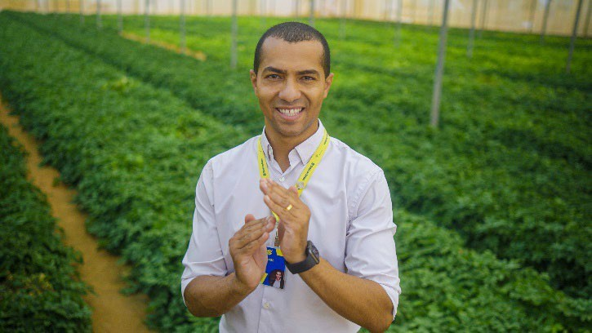

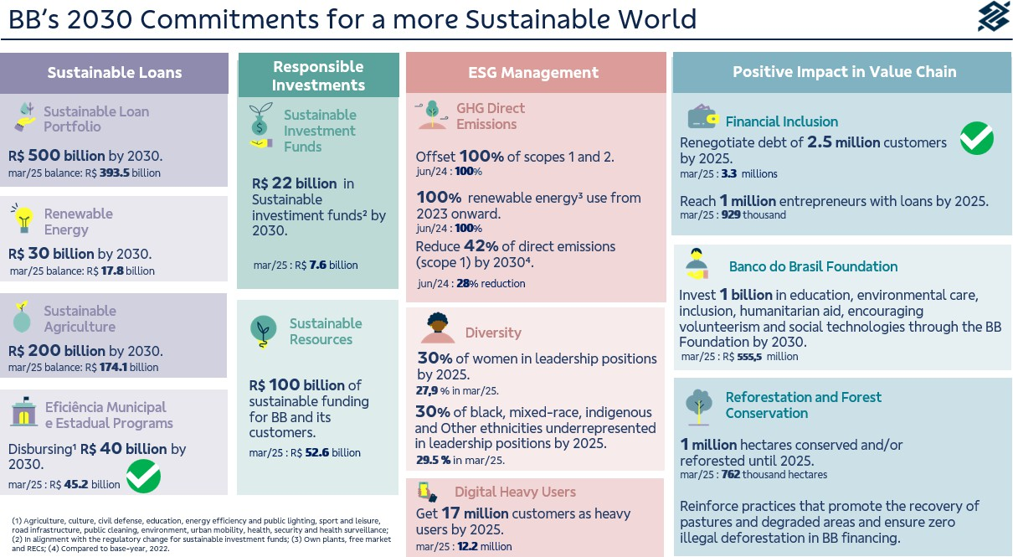

Sustainable Business
In line with our long-term commitments and aiming to help clients in the transition to a more sustainable economy, by the end of March 2025, we had reached R$393.5 billion in sustainable credit operations, a growth of 9.6% in 12 months. This amount was contracted in credit lines with an environmental or social focus, aimed at financing activities that promote positive socio- environmental impacts.
The sectors benefiting include renewable energy, energy efficiency, sustainable construction, transportation and tourism, water, fishing, forestry, sustainable agriculture, waste management, education, health and local and regional development, thus reinforcing the transformative role in the country's development and in building an increasingly sustainable future for society.
The Sustainable Credit Portfolio is subject to an independent assessment, which considers the main

national and international ESG taxonomies in the classification of clients and credit lines that make up the portfolio. The methodology is continually reviewed to incorporate best practices and pioneering references from recent years and to include new products with ESG attributes.

Bioeconomy and Value Chain
We have contributed to the development of biodiversity in the country, providing financial resources, specialized services, credit lines with attractive conditions and financial consulting services to assist family farmers, associations and cooperatives that work with the Bioeconomy. We are currently one of the main financiers of forest- compatible products, with R$1.9 billion in bioeconomy and value chain projects in the Legal Amazon Forest, representing a growth of 39% in the last 12 months.

Carbon Market
We have strengthened our presence in the voluntary carbon market, supporting clients in developing projects that generate carbon credits with significant environmental additionality, offering advice on carrying out GHG emissions inventories and decarbonization plans, and offering carbon credits from high-integrity projects to offset unmitigated emissions.
In addition, we offer intermediation opportunities between those who need and those who have carbon credits. We have specific lines to promote projects that contribute to decarbonization, such as renewable energy and energy efficiency.

Until March 2025, more than 762 thousand hectares have been preserved or reforested through carbon projects and credit operations.

Forest conservation carbon projects (REDD+) combine environmental preservation and income generation for landowners.
Aiming to diversify the sources of carbon credit generation, in March 2024 we launched the Biogas Program, which supports the development of projects based on the generation of biogas and biomethane in agriculture, especially with swine farmers and cattle.
In line with diversification, we formalized five projects in the soil carbon modality (ALM) for the recovery of degraded pastures, totaling an area of
46 thousand hectares, contributing to more sustainable agriculture and generating additional income for producers.

Diversity, Equity, and Inclusion

We remain committed to diversity. Currently, women represent 44% of the Board of Directors and 50% of the Board of Directors (CA). In addition, two members of the Board of Directors and two of the CA identify as black. Two members of the Board and two of the CA identify as members of the LGBTQIAPN+ community.
BB has one of the most diverse workforces in the market, endorsed by B3, through iDiversa.
As a practical action of the Memorandum of Understanding signed in November 2023, in February, through the Foundation and Zumbi dos Palmares University, we announced the opening of a selection process for a research scholarship, aimed at black people pursuing master's and doctoral degrees. With the theme “Studies on the impact of beauty and aesthetic activities on income generation for black people in the outskirts of cities”, the research aims to foster the production
of scientific knowledge and encourage productions that highlight Afro-Brazilian culture.
In March, we actively participated in the 69th Commission on the Status of Women, in New York, strengthening the advancement of gender equality in the world.
Also in March, we hosted, at our Headquarters, the workshop on Future Scenarios for the Black Population in Brazil, an initiative of the Guetto Institute and the National Anti-Racist Front, with the methodological support of Reos Partners. The goal is to build a set of relevant scenarios about what could happen to the black population in Brazil over a 25-year horizon.
In this quarter, we implemented the Regional Forums on Diversity, Equity and Inclusion (DE&I) and Employee Experience (EX) that complement and strengthen the governance structure in DE&I,

created in the Diversity Program, launched in March 2023.
In the same period, we participated in two meetings of the State-Owned Companies Pact, in January and March, the latter of which was held at
BB's headquarters in Brasília, bringing together dozens of federal state-owned companies that signed the Pact in September 2024, with the aim of exchanging experiences and promoting good practices in Diversity, Equity and Inclusion.

Independent Audit
BB strictly follows all applicable laws and regulations for independent auditing, ensuring transparency and compliance in the processes. KPMG Auditores Independentes Ltda. is the company hired to provide external audit services for the financial statements.
Regarding the non-audit services provided by it within the scope of BB, they do not represent a conflict of interest nor do they compromise its independence in the execution of the work. Information on fees for non- audit services is disclosed annually in our Reference Form, in accordance with CVM Resolution 162/2022.

Additional Clarifications
We have R$1.2 billion (consolidated) in unrecovered tax credits, as shown in Note 22 - Taxes (subitem “f”). In compliance with article 243 of Law 6,404/1976, we hereby inform you that the company's investments in affiliated and controlled companies are listed in Notes 2 - Presentation of Financial Statements and 14 - Investments.
We publish annually the investments made in public policies in our Annual Letter of Public Policies and
Corporate Governance, available on the website ri.bb.com.br.
Banco do Brasil, its shareholders, directors and members of the Fiscal Council undertake to resolve any and all disputes or controversies related to the Novo Mercado Regulation through the B3 Arbitration Chamber, in accordance with the arbitration clause contained in Banco do Brasil's Bylaws.
This Management Report was prepared based on the Individual and Consolidated Financial Statements prepared in accordance with the Accounting Standards for Institutions Regulated by the Central Bank of Brazil (Cosif). For more information, the Reference Form, the Performance Analysis Report and the Institutional Presentation are available at ri.bb.com.br.

Acknowledgements
We remain committed to offering innovative solutions, driving growth and excellence in our services. Thank
you for following this report and being part of our journey.

