Banco do Brasil S.A. - Management Report – 9M23

Dear Reader,

In the nine months of 2023, we registered a net income of R$25.0 billion. This result reflects the discipline in the execution of our strategic planning. We seek excellence in service and relationships, in an innovative and efficient way, bringing hyper-personalized solutions, so that we can see Brazilians prospering more and more.
We reached R$64.4 billion in added value to society, through the payment of dividends, taxes, and other components. In addition, we adopt actions that generate positive social and environmental impacts through our initiatives, partnerships and the work of the Banco do Brasil Foundation. We encourage sustainable best practices and support our clients to migrate to greener and more inclusive business models.
In September, we participated in several meetings at the United Nations (UN) headquarters, in an event that preceded the General Assembly and brought together heads of state and civil society representatives from the more than 190 member countries of the Organization. We came to New York as a relevant player in sustainable investing. As a result, we foster business, prospect investments and new sources of financing, in addition to promoting the dissemination of BB's sustainability agenda to the international community.
On the occasion, memorandums of understanding were signed with multilateral organizations aimed at raising funds with a focus on promoting sustainable best practices and the preservation of the Amazon biome. This volume is in addition to the values prospected on a trip to Asia in July.
Also in New York, we took to the world the need to preserve the forest, the recovery of degraded forests, the promotion of the bioeconomy and the appreciation of the Amazonian population, through the All Amazônia campaign, a global call with an audiovisual manifesto on the screens of Times Square and on our communication channels, engaging customers, investors, and representatives of civil society.
In addition, we have maintained our relevant and historical role in the field. In the first three months of the Crop Plan, a total of R$68.8 billion was disbursed, representing an increase of 8.2% compared to the same period of the previous year, with more than 180 thousand operations carried out.
BB's actions work with micro, small and medium-sized companies are also highlighted. In one year, we grew the balance of operations for these customers by 14.2%, supporting the segment that generates the majority of the jobs in our country to continue growing. In the case of micro and small enterprises, an important part of the credit support is carried out with companies led by women.
In July, the Desenrola Program was initiated in the country, a coordinated action in which the market, government and other leaders of public life are acting in unison, contributing to millions of Brazilians getting out of default and being able to rescue their financial dignity and that of their families.
Our performance in credit to the Public Sector is also worth mentioning. We strengthen our partnership with public entities, which enable public policies and improve the lives of citizens. We contracted more than R$16.7 billion in credit operations with States and Municipalities in the first nine months of 2023, a relevant growth compared to the same period in 2022.
Finally, we highlight that we ended the month of September with the review of our 2024-2028 corporate strategy so that we are always increasingly a close and relevant bank in people’s lives.
We invite you to learn a little more about Banco do Brasil's achievements on the following pages, while reinforcing our commitment to generating value for all our stakeholders.
Good reading!

Consolidated Financial Statements Results
Main components and performance indicators in the first nine months of 2023, compared to the same period in 2022.

We presented a Net Income of R$25.0 billion in 9M23 which reflects the good commercial performance in the various business segments, notably in the provision of quality credit, operating in the value chains and a mix appropriate to the profile of our portfolios.
This performance is reinforced by the diversification of revenues from services, while administrative expenses remained under control. The proper management of liquidity and the results of the group's companies add to our performance.
Our classified loan portfolio reached R$945.5 billion, up 9.8% from September/22. The portfolio for individuals, excluding rural producers, grew 7.8%, with payroll-deductible loans standing out. On the other hand, the companies portfolio, excluding agribusiness companies, grew 6.0%, highlighted by the balance with SME customers, which increased by R$15.1 billion. Credit operations with producers and agribusiness companies grew by 17.0% in the same period.
The Capital Adequacy Ratio reached 16.24% and the CET1 ended September at 12.49%.
To learn more details about the income and equity items for the period, read the Explanatory Notes contained in the Financial Statements for the period and the Performance Analysis Report.
Value Added
R$64.4 billion
Growth of 10.5% compared to 9M22
Net Income
R$25.0 billion
Growth of 10.9% compared to 9M22

Shareholders and Holders of Debt Instruments
We have a base of more than one million shareholders, 98.6% of whom are individuals and 1.3% are legal entities. At the end of September, our shareholding structure was distributed between 50% of shares held by the Federal Government, 49.6% in circulation (free float) and 0.4% held in treasury. Local investors held 74.5% of the shares, and foreigners 25.5%. Our shares (BBAS3) accounted for 3.477% of the Ibovespa in the last four months.

Remuneration to Shareholders
The Shareholder Remuneration Policy seeks to ensure the due valuation of the shareholder, combined with the continuity and financial sustainability of the Bank in the short, medium, and long term, based on the premise of flexibility and financial solidity that ensure the sustainability of the business.
For the 2023 fiscal year, the distribution of dividends and/or Interest on Equity (JCP) corresponding to 40% of net income, adjusted as provided for in letters "a" and "b" of item I of article 202 of Law 6,404/76, was approved, based on the Bank's results, its financial condition, cash requirements, the Capital Plan and its goals and respective projections, the Risk Appetite and Tolerance Statement, perspectives of present and potential markets, existing investment opportunities and the maintenance and expansion of operational capacity. The total allocated to shareholders in 9M23 was R$9.7 billion and the value per share was R$3.389.

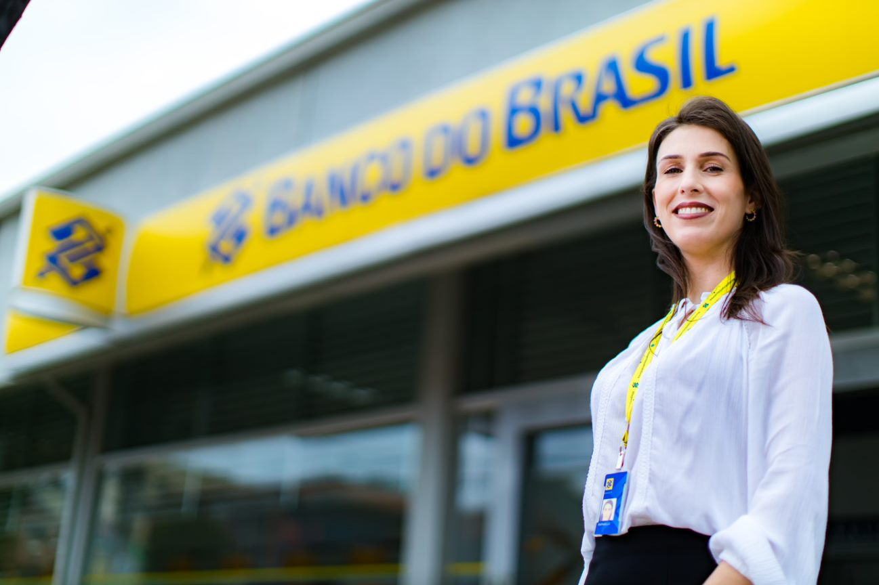

Corporate Strategy


Our Corporate Strategy (ECBB) has a five-year time horizon and is reviewed every year through a structured, participatory process using consolidated methodologies.
The latest review, focusing on the 2024-2028 period, was approved in September, establishing the following strategic objectives: (a) to provide the best experience to customers at all times; (b) create value and generate sustainable results; (c) to be a protagonist in sustainability and in the promotion of ESG business and practices; (d) evolve the way we work to accelerate digital transformation and innovation; and (e) have people engaged with BB's values and promote collaboration, respect and inclusion.
The construction of the ECBB 2024-2028 had an innovative dynamic, and this edition is the most collaborative so far. The beginning of the process was built with the direct participation of officials from all over the country. The contributions were significant – the SWOT matrix, for example, was formulated based on the more than seven thousand interactions received, with the employees' perceptions of our Company, the challenges, opportunities and trends for the future.
In the refinement stage, the members of the executive board, presidents of entities linked to BB, executives and a group of superintendents jointly debated and built the definition of key indicators and results for five perspectives: Customers, Financial, Sustainability, Digital Transformation and Processes, and People and Culture. In September, the ECBB was approved in a collegiate manner, both by the of Officers and the by the Board of Directors.
Our purpose is "To be close and relevant in people's lives at all times", and that's why we exist, to always be together, to support and maintain close relationships with people, regardless of the channel. We are relevant, because our greatest aspiration is to generate value and be indispensable in the lives of the people with whom we relate. We want this purpose to be present in our relationships at all times, as we offer complete solutions so that people can count on us during all phases of their personal and professional lives.
In line with our purpose and reinforcing the Company's organizational identity, we have improved our values to make even clearer the unique principles that guide our performance and inspire our team's deliveries, with emphasis on the new value included: diversity. Thus, our values are Proximity, Innovation, Integrity, Efficiency, Commitment to Society and Diversity.
The Strategic Map, composed of the Strategic Objectives and the Master Plan, outlines the strategic guidelines, indicators, and respective goals for the next five years, distributed in the five perspectives. The customer is at the center of our performance and decisions at all organizational levels, receiving complete solutions and an appropriate experience. We are a competitive, profitable, efficient, innovative bank, a benchmark in sustainability and ESG business, the result of excellence in the optimized allocation of capital, high operational efficiency, a rational organizational structure, the development of new businesses and diversified sources of revenue.
We accelerate digital transformation and innovation, using analytical intelligence and focusing on improving models, processes, products, and channels, with the aim of making them simpler, more agile and responsive, thus creating a bank for each customer.

Clients
A bank for every client
We look at our clients in a broad way, breaking down traditional segmentation barriers and getting to know their interests, consumption habits, lifestyle, values, and affinities. With the extensive use of data, we know and value what is important to each customer, fostering a close relationship that goes beyond core banking.
Applied analytical intelligence allows us to further personalize the relationship, generating good experiences and relevance, so that customers have access to a highly specialized Bank, with products, services and advice tailored to their needs.
In recent years, there has been a significant evolution in the migration of transactions to digital channels, however, at the same time, human contact, by physical or remote means, remains relevant for advice, business and demands of greater complexity. Complementarity is necessary for the experience to be fluid, both in digital self-service and in face-to-face or remote service.
Active listening and understanding of our customers' needs are at the heart of our actions. After each service performed, we send an evaluation survey to the customer and the grade received is linked to the evaluation of the employees' semiannual performance, to ensure that the quality of service and customer satisfaction are a common goal for all. The consequence of the constant monitoring of customer needs and satisfaction is reflected in the decrease in complaints to the Customer Service, the BB Ombudsman and the better positioning in the Central Bank ranking.
Seeking to deliver a unique, integrated experience aligned with customers' goals and moment of life, we are enhancing our CRM, which was developed in a proprietary way, to a market-leading cloud solution. Allied to this transformation, we are also investing in a new service platform solution that allows us to embed analytical intelligence applied to our employees' interactions, ensuring excellence in the relationship with our customers.
We continue to advance in the migration of the service structure to lighter, more efficient and specialized models, which results in a comprehensive experience in the channels and expands our capillarity, ensuring the best convenience for customers. BB has enabled business and innovations to always be close and available to customers, whether they are in branches, in the App, on social networks or in the metaverse.
Our initiatives to improve the customer experience have shown positive results in terms of satisfaction, which has been reflected in our Net Promoter Score (NPS).
In line with the Corporate Strategy and customer centricity, our Ombudsman offers complete solutions to our stakeholders. As of this quarter, the Internal and External Ombudsman offices work under the same unit, with the objective of bringing a holistic view in the treatment of customer and employee demands, seeking to increase satisfaction and resolution of demands.
To generate value and seek lasting solutions, we held meetings and workshops during the quarter with the objective of receiving information and intelligence on how to improve our service and reduce customer complaints, as well as improvements in conflict mediation and risk mitigation, to increase the perception of value by customers and increase BB's NPS. Employees from more than 2500 agencies participated.
The integrated work between customer service employees and the Ombudsman's Office shows results, such as in the Bacen ranking, where BB continues to be the only large financial institution with a single-digit ratio of occurrences per million customers (8.99), for the fourth consecutive quarter.

Digital Transformation
Our technology areas work in harmony with the business and customer areas, with the aim of promoting the best experience for our customers at all points of contact, whether physical or digital.
We have increased investments to improve our technology and accelerate our digital transformation, bringing new fronts of engagement, new ways of doing business and working, supported by our cultural transformation.
In this context, we completed one year since the launch of the roadmap to accelerate our digital transformation with short, medium, and long-term investments and actions, through the agile operating model. In the first wave, lines of business and platforms were prioritized, considering their relevance to the result and the ability to impact the increase in the value generated for customers, employees, and shareholders.
We realize the value of data as a strategic asset and understand that the use of Analytical Intelligence contributes to better customer knowledge, to the development of new business and to the improvement and expansion of existing products and services.
Among the main uses of analytical intelligence are solutions for hyper-personalization of offers and conditions made available to customers, advisory models and indication of the best channel and moment of contact. With this, we are more assertive and strengthen the long-term relationship with our customers.
Other examples of the use of analytical intelligence are the modernization of credit risk models, such as those we developed for the Desenrola Brasil Program, and the expansion of credit limits with security and agility, supporting the establishment of R$158 billion in margin for contracting in the year. Also noteworthy is cash management through predictive analytical models that indicate the personalized needs of each service point. This movement alone foresees an annual saving of approximately R$40 million in efficiency.
The Business Coach, is a system developed by analytical intelligence that provides a message with alerts and management tips, prepared from cash flow, sales and customer data, with the objective of supporting companies in the management of their business, through personalized and useful information for the day to day.
We also have a robust Analytics Platform, which has a wide menu of solutions and tools such as labs, no-code tools and AutoML (Automated Machine Learning), which have contributed to expanding maturity and analytical capacity in all areas and all organizational levels.
As of September 2023, we had 27.6 million active customers on digital platforms. Transactions carried out in these channels accounted for 93.1% of our clients' operations, compared to 92.7% in 2Q23.
We reached a record number of 22.8 million users on the App. The customer not only makes inquiries, but also buys, invests, and makes their financial transactions through the BB app.
Digital platforms accounted for 33.2% of personal credit disbursements and in 3Q23 alone, 28% of service operations (such as investment, card application, account opening and capitalization business, insurance and consortia) were carried out through these solutions.
We have one of the largest technology parks in Latin America and our App is one of the best evaluated in the financial market (rating of 4.6 on Google Play, carried out by more than 6.18 million users, and 4.7 on the App Store (Apple), with 2.95 million reviews), on a scale with a maximum score of five stars).
We continue to stand out as one of the most relevant Open Finance institutions in Brazil and abroad. In the quarter, BB reached the milestone of R$2.3 billion in increased credit limits for individuals, based on information shared via Open Finance, an increase of 35% compared to the previous quarter. With new use cases for data shared with Banco do Brasil, the adhesion of new customers to Open Finance continued at a fast pace.
By the end of 9M23, we had about two million unique customers sharing data and more than three million consents.
Since September, our client has been able to simulate and contract their credit portability via App, using Open Finance data. This solution reinforces the "phygital" strategy, by offering the customer the same product and contracting conditions in the channel they prefer. The solution brings convenience and a fluid experience, with less friction, by using data directly from the other institution to perform the simulation and compare operations. In terms of Portability operations with Open Finance, we already have more than R$600 million disbursed.
Combined with Open Finance, the MPE client has a global view of their enterprise, regardless of where they have an account, bank card domiciles and POS machines.
Launched in November 2021, Loja BB became Shopping BB in April 2023, reflecting the continuous improvement of our strategy as a bank as a platform. Since launch, more than 4.6 million customers have had the experience of acquiring non-financial products and services, demonstrating and expanding our operations beyond the banking core and expanding the relevance of our platforms to customers.
This is a Baap (Bank as a Platform) strategy in which we will continue to invest for a greater diversity of solutions and presence in the daily lives of our customers, whether companies or individuals.



ESG (Environmental, Social and Governance) Agenda

We adopt the best Environmental, Social and Governance practices that establish actions to identify and manage risks and opportunities. Our ESG premises are embodied in the BB Agenda 30 Sustainability Plan, which since 2005 has been our main instrument for promoting social and environmental practices, in line with the Sustainable Development Goals (SDGs) of the United Nations (UN) and the Paris Agreement.


Our commitment to developing business solutions with social, environmental and climate aspects is guided and declared in our Social, Environmental and Climate Responsibility Policy (PRSAC) and also based on the BB Sustainability Guidelines for Credit, which are in synergy with the international commitments assumed by the Federal Government, including those related to mitigation and adaptation to the effects of climate change. With a national spotlight on the development of financial solutions and business models that promote the transition to a sustainable and inclusive economy, we consider climate change in planning and seize business opportunities for a low-carbon economy.

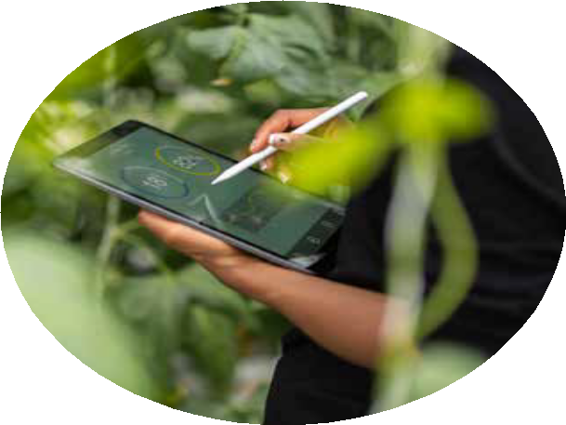

For the period 2023-2025, we have updated our Sustainability Plan - BB Agenda 30, resulting in 47 actions and 100 indicators, which already reflects the premises of the global 2030 Agenda and meets the international call to build a world guided by the proper management of natural resources, respect for human rights and the generation of value for society and the environment.

BB 2030 Commitments for a + Sustainable World
We renew and revise our commitments for a sustainable future. The BB 2030 Commitments bring objectives on four fronts: (i) sustainable credit, (ii) responsible investment, (iii) ESG and climate management, and (iv) positive impacts on the value chain.
The defined goals are in line with the Sustainable Development Goals (SDGs) of the United Nations (UN) and are part of our Sustainability Plan, Agenda 30 BB.
The fulfillment of sustainability indicators and goals are reflected in the compensation of the entire staff, including senior management, which ensures alignment between business, people, and social, environmental, and climate issues.
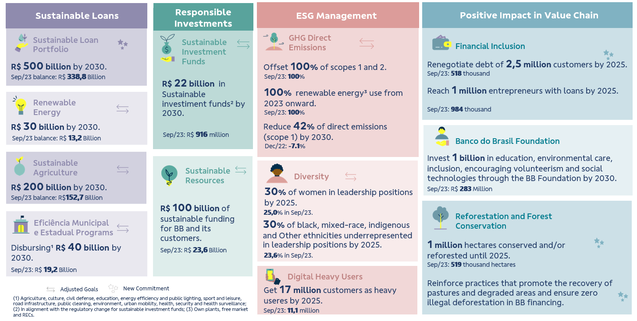
Sustainable Funding

In April 2023, the first Social Bond Resource Allocation and Social and Environmental Impact Report was launched. The document complies with the premises of BB's Sustainable Finance framework and received the opinion of the independent auditor's limited assurance.
Also in April, BB issued the second international bond under the Sustainable Finance framework. The international funding of senior debt, of the sustainability bond type, in the amount of US$ 750 million, matures on April 18, 2030 and has a coupon of 6.250% p.a. The funds raised will be allocated to renewable energy projects and to the financing of micro and small enterprises, especially those led by women.
In September 2023, Banco do Brasil and the Inter-American Development Bank (IDB) signed a letter of intent to enable a financing partnership in the amount of US$250 million, which is part of a Conditional Credit for Investment Projects (CCLIP) line worth up to US$1 billion.
The operation should promote bioeconomy and sustainable infrastructure initiatives, with an emphasis on connectivity and renewable energy sources for the Legal Amazon. The announcement was made during a meeting between IDB President Ilan Goldfajn and President Tarciana Medeiros in New York.
The initiative aims to promote an inclusive and sustainable development model in the region based on two components. The first is to support the development of companies and rural producers that are part of the value chains of the Amazon bioeconomy. The amounts consist of resources from the IDB and the Green Climate Fund.
In addition, BB is advancing in cooperation with the World Bank (WB) aimed at the transition to a low-carbon economy and the promotion of projects for the recovery of degraded areas in the Legal Amazon region.
This front of action seeks to identify sustainable solutions for forest restoration and the promotion of sustainable low-carbon agriculture, with a special geographic focus on the Legal Amazon region in support of the National Plan to Combat Deforestation in the Amazon (PPCDAM).
The objective is to identify and explore financial opportunities for technical assistance, together with other public and private partners at the regional, state and national levels, to develop value chains, increase economic opportunities, maintain biological, cultural and social diversity, and reduce greenhouse gas emissions.
During Climate Week in New York, Banco do Brasil and BMO Financial Group (BMO) signed a Memorandum of Understanding to grant Sustainability Linked Trade Loans for Advances on Foreign Exchange Contracts ("ACC") and Advances on Foreign Exchange Delivered ("ACE"), with an emphasis on the export of products from sustainable production and agriculture systems.
The new operation, unprecedented in the Brazilian market, seeks to foster the export chain of sustainable and Brazilian products, encouraging better trade finance practices and supporting the supply of certified and quality products to the main world markets. Among the innovations, differentiated conditions will be offered for ACC/ACE's operations, if it is proven that sustainability goals have been achieved in line with BB's commitment to sustainable agriculture and agreed between the institutions.

Sustainable Credit Portfolio

In our BB 2030 Commitments, we stated the objective of reaching R$500 billion in sustainable credit by 2030. At the end of September 2023, we reached a portfolio of R$338.8 billion in sustainable credit operations, a growth of 5.5% in 12 months. This amount was contracted in credit lines with a strong environmental and/or social focus or to finance activities and/or segments that bring positive socio-environmental impacts, such as the sectors of renewable energy, energy efficiency, construction, sustainable transport and tourism, water, fisheries, forestry, sustainable agriculture, waste management, education, health, and local and regional development, in order to reinforce our transformative role in the country's development and construction of an increasingly sustainable future for society.
Our Sustainable Credit Portfolio is subject to an independent assessment, which considers the main national and international ESG taxonomies in the classification of customers and the credit lines that compose it.
Energy Eco-Efficiency
Considering BB 2030's commitment to a more sustainable world, we are investing in decarbonization, and we guarantee that 100% of the electricity consumed by BB comes from renewable sources. We migrated 67 administrative buildings to the Free Contracting Environment (ACL), ensuring the consumption of clean energy and obtaining accumulated savings of R$65.1 million, with a forecast of R$120.4 million by 2025. In the first half of this year, we expanded the ACL project to three consumer units, and we have plans for nine more, which means clean energy for 12 dependencies by the end of 2023. This year, we have already inaugurated five solar plants – the twelfth since 2020. All mills have a social counterpart.
BB's solar plants have already generated about 43 GWh, avoiding the emission of more than 13,000 tons of CO2 into the atmosphere, equivalent to planting a small forest of 2,000 trees. In addition to the environmental gains, we saved R$16.6 million, a saving of 28% compared to the captive market, to achieve an expected reduction of R$629 million in 15 years.

Corporate Governance

We adopt the best corporate governance practices, maintaining our commitment to the principles of transparency, accountability, equity, and corporate responsibility. Since 2006, we have been listed on B3's Novo Mercado, the segment with the highest standard of corporate governance.
Decisions are taken collegially at all levels. Thus, the management has a structure of committees, subcommittees and strategic commissions that ensure agility, quality, and security in decision-making.
Our governance structure is composed of the General Shareholders' Meeting; the Board of Directors (BoD) and its advisory committees – Audit Committee (Coaud); People, Compensation and Eligibility Committee (Corem); Risk and Capital Committee (Coris), Technology and Innovation Committee (Cotei) and Corporate Sustainability Committee (Cosem); the Executive Board, composed of the Board of Directors (President and Vice-Presidents) and other Executive Officers; and the Fiscal Council.
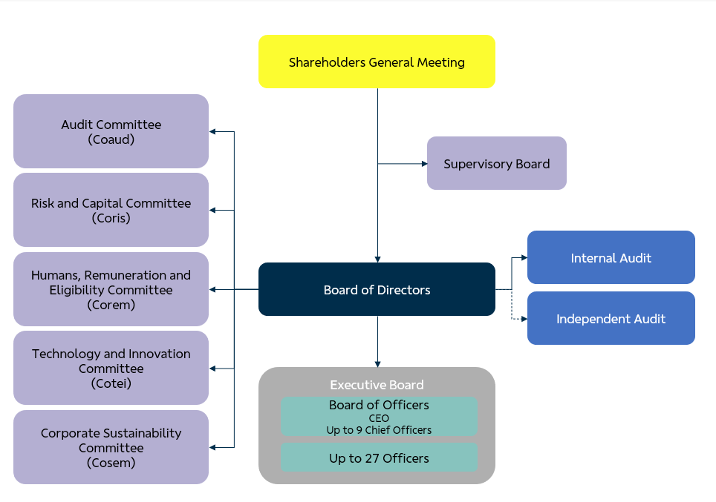
The Board of Directors, an independent body of collegiate decision-making, has, as provided for in the Law and in the Bylaws, strategic, guiding, elective and supervisory attributions. At least 30% of the members are independent, as defined in the legislation and in B3's Novo Mercado Regulations. In this sense, in April 2023, we held a General Shareholders' Meeting to elect the directors for the 2023/2025 term, at which time those appointed by the controlling shareholder and minority shareholders were elected.

We published the Annual Letter on Public Policies and Corporate Governance in May 2023. It discloses, among other information, BB's commitments to the achievement of public policies, as well as the corporate governance practices adopted. The document is available on our Investor Relations website.
In that year, the BB Annual Letter included information on the contribution generated by the Bank to society, evidenced by an accounting report called the Statement of Value Added, the Bank's performance in the Federal Government's popular housing program and reference to products and services with social and environmental attributes that are associated with public policies.


Diversity, Equity, and Inclusion

In line with our strategy of acting on issues related to corporate sustainability, we have expanded our structure and team focused on the Environmental, Social and Governance agendas, covering topics of diversity, equity, inclusion, and the expansion of sustainable businesses.
In addition, with the revision of our strategy (2024 – 2028), we incorporate diversity as a value that forms the basis of our culture, is experienced by all our employees and dialogues in our actions with all our stakeholders.
Also, last quarter, we became ambassadors of the United Nations (UN) Global Compact related to racial equity, gender and decent work: They Lead 2030, Race is a Priority and Living Wage.
The adhesion was announced on August 29 and, as ambassadors of these movements, we are committed to taking these causes beyond our doors, mobilizing the entire value chain that surrounds it and leading initiatives that impact the entire Brazilian society.
The Women Lead 2030 movement is linked to Gender Equality, one of the Sustainable Development Goals (SDGs), and aims to help companies achieve goals for equality between men and women. The Living Wage seeks to ensure 100% fair remuneration for male and female employees, including operations, contractors, or contractors, and to engage the entire supply chain in the goals to achieve the SDG Decent Work and Economic Growth.
The Race is a Priority movement works to promote more black, indigenous, quilombola or other underrepresented ethnic groups in leadership positions by 2030.
Diversity Recognitions
We were selected to be part of B3's iDiversa, the first Latin American index to combine, in a single indicator, gender and race criteria, and recognizes listed companies that stand out in diversity, in addition to promoting greater representation of these groups in the market.
The index was constructed based on public data available on the Reference Form of companies listed on the stock exchange. BB has a weight of 4.71 in the first portfolio disclosed.
In October, during the CEBDS 2023 Sustainable Congress, we received two awards recognizing the advances in diversity in BB's management: Women on the Board, for the 50% of women among the eight members of the Board of Directors, and Female Leadership, where the Bank reached 44% of women on the Board of Directors.

Sport & Culture
We believe that sponsoring sports brings rejuvenation to our brand and associates us with attributes that we consider important, such as: quality of life, sustainability, and preservation of the environment.
We are one of the biggest supporters of Brazilian sports, including Olympic sports, among the sponsored modalities are volleyball, surfing, skateboarding, and street running. We also support eSports, as well as individual athletes sponsored in different sports.

We recognize that sport teaches, entertains, makes dreams come true, stimulates unity, and maximizes achievements. The goal of the incentive is to continue exciting, surprising, helping to develop sports and, above all, projecting new idols.

We believe that culture generates connection. She inspires, sensitizes and creates a repertoire. It promotes critical thinking and has the power to impact lives, so we promote access to national and international cultural productions, through a simple and inclusive approach that provokes identification and representativeness.
We are present, with the Banco do Brasil Cultural Centers (CCBB), in four major Brazilian capitals – Rio de Janeiro, São Paulo, Brasília and Belo Horizonte. From January to September 2023, we received more than three million visitors, with the realization of more than 250 projects in the areas of performing arts, music, exhibitions, cinema, ideas and actions of the educational program. With this, the CCBBs consolidate themselves as one of the main cultural centers in the Brazilian and international scenario.
The highlight this year is the launch of the Cultural Sponsorship Notice to compose the CCBB program in the 2023-2025 period. More than R$150 million will be allocated in three years, with more than 6.6 thousand projects registered - with emphasis on the North and Northeast regions, which had a record number of registrations.

Awards & Recognitions

January
For the tenth consecutive time, we have been recognized with the Top Employers certification, an award granted by the Dutch independent research foundation Top Employers Institute. We are the only Brazilian company certified in all editions and we have been recognized as an employer that develops talent at all levels of the organization and that strives to continuously implement and optimize people management policies and practices.
We have been listed in the annual global 500 ranking, which recognizes the 500 most valuable brands in the world. The assessment is from the British consultancy Brand Finance and the result was released during the Davos Economic Forum in Switzerland.
We are ranked, for the fourth time, as the most sustainable bank on the planet by the ranking of the 100 Most Sustainable Corporations in the World 2023 – Global 100, by Corporate Knights. In 2023, in addition to its leadership position among banks, BB is the only Brazilian company classified, ranking 15th among companies in general.
The Private segment was listed in the 2023 Ranking of Leaders League, in the Wealth Management - Private Bank Brazil category, which recognizes the best strategies in Brazil in wealth and wealth management for Private clients.
February
We received international recognition in the Platinum and Gold categories of the 2023 AVA Digital Awards, which takes place in the United States. Awards from all over the world are evaluated by professionals who work in the U.S. communication and marketing market.
We were recognized in the Lusophone Creativity Award, when seven initiatives won 13 trophies, in various categories.
For the 2nd consecutive time, we won the award for the Most Sustainable Bank in South America, by Capital Finance International – CFI.co.
March
Abrarec – Brazilian Association of Company-Client Relations announced the winners of the Ouvidorias Brasil Award and we won the best innovation case in Ouvidorias Brasil for the 10th time.
It won the bronze trophy at the 17th Steve Awards for its comprehensive accessible care for deaf and speech-impaired people. The event that took place in the USA recognized the service in Libras in the category of Innovation in Customer Service in the Financial Services Industry.
Our Private segment was recognized for the second year in a row as the best Private Bank in Brazil in 2023 by World Business Outlook, a media outlet specialized in covering and analyzing finance, international business and the global economy. In this same award, 2023 edition, we were also recognized in the categories Best Private Bank for Women, Best Private Bank for Succession Planning and Most Sustainable Private Bank in Brazil.
April
Our president, Tarciana Medeiros, leads the reputation ranking of Forbes Brazil, is the CEO with the best reputation on LinkedIn according to Forbes Brazil magazine. The ranking scores were calculated using the Digital Maturity Matrix, a methodology that analyzes the presence and strategy of leaders in a qualitative and quantitative way. The Matrix considers more than 30 criteria and parameters in the dimensions of presence, strategy, social capital, and reputation of executives, delivering a holistic view to the analysis and bringing an effective evaluation to the strategy of leaders and brands on LinkedIn.
We were recognized in the Private segment as Brazil's Best Institution in Innovation focused on Wealth Management at The Global Economics Awards 2023, organized by the media outlet specialized in the financial market and with international coverage.
May
The Central Bank awarded the institutions that obtained the best performance in the 2022 Annual Ranking of projections of the Focus Bulletin. We won the 1st place in the classification for the Selic Rate. BB Asset, on the other hand, was recognized for 1st place in the IPCA – Medium Term Regulated Prices projection.
We won the fourth championship in one of the categories of the Global CCU Awards, which is an award that recognizes the best corporate universities on a global scale, which create strategic value for people, business, society and the planet. Gold came in the Impact Technologies category, with the Academia de Educadores project as the best Private Bank in Brazil in the 2023 edition of the World Business Outlook Awards, organized by the media outlet specializing in the coverage and analysis of finance, international business, and the global economy.
June
Our president, Tarciana Medeiros, received the Personality of the Year award, offered by the Brazilian Chamber of Commerce in the United Kingdom in recognition of the achievements of companies and their leaders who have contributed to strengthening trade ties between Brazil and the United Kingdom.
We won the 11th edition of the Global Finance Award – The Innovators 2023, in the category "Top Innovations in Finance 2023 - Marketing" with the case "Metaverse BraBlox", whose proposal is to connect the young audience to the company's brand, so that in the future they can become customers of the Bank.
We won the 2nd edition of the FIDinsiders 2023 Award - Digital Finance for Society in the category "Innovation in the Offer of Financial Solutions for Small and Medium Rural Producers". The FIDInsiders Award aims to recognize and disseminate innovative solutions that contribute to improving the democratization of finance in Brazil.
We also had a better score in the ESG rating by Sustainalytics, reaching the "Low Risk" rating and a score of 19.3 (in 2022 we scored 20.6 - Medium Risk). The assessment reflects BB's performance on issues such as data privacy and security, governance, business ethics, risk management, social and environmental performance, among others.
We won the Latam 2023 Award, offered by the Alianza Latinoamericana de Organizaciones para la Interacción con Clientes (Aloic), the award recognizes the best practices in customer relations on the continent.
We were recognized, with the gold trophy, for the best performance in South America in innovation for customer service in the 21st edition of CMS Financial Innovation.
July
We were nominated again for the ReclameAqui award, in the Banks category, demonstrating our good reputation in the opinion of consumers. To be nominated to participate in the awards, companies must have status: Good, great or be RA 1000 (maximum reputation seal provided by the website). The ReclameAqui Award is in its 13th edition, and this is the 5th consecutive time that BB is nominated for this category.
We were listed for the eighth consecutive year in the FTSE4Good Index Series, an index of the London Stock Exchange that evaluates and ranks companies with the best environmental, social and corporate governance practices. 2. BB obtained an overall score of 4.1 in 2023, compared to 3.6 in 2022, and achieved a maximum score (5.0) in the environmental dimension.
We had another international recognition, this time as the best Brazilian bank in the corporate governance category, conferred by the Global Banking & Finance Review. The British Global Banking & Finance Review is an international online platform that offers news, analysis and opinions on the latest trends and innovations in the banking and finance sector around the world, presenting and discussing topics such as banking, insurance, investments and wealth management, as well as discussing fintechs, banking technology, regulatory issues and corporate social responsibility (ESG).
August
We were recognized by the Brazilian Institute of Public Governance (IBGP) with the Innovation in the Public Sector with a focus on the citizen award. The SisconDJ-WEB solution was awarded in the State-Owned Companies Category. Through the Interconnection with the Courts of Justice and Regional Labor Courts solution, the entire process of payment of permits for beneficiaries is done directly by public servants and judges, without the intervention of our network of agencies.
September
We held a webinar alluding to Yellow September, bringing tools to help those who need emotional support. We expanded remote work, reaching more than 16 thousand employees in order to provide a better quality of life to employees, in line with the objectives of the Corporate Strategy - ECBB by contributing to digital transformation and innovation, in addition to enabling the reduction of expenses with the rental of physical spaces.

People Management

The labor market evolves, following needs, trends and new technologies, and BB is a protagonist in this evolution. We live in an era in which transformations happen more quickly and responses must follow the same pace.
This transformation also occurs through digital acceleration, which positively influences the way we work, with the use of agile methods on a daily basis and seeking the reskilling and upskilling of our teams. In addition, the latest competitions, held in 2021 and 2022, oxygenate our staff with the arrival of new professionals, including directly for the areas of technology and cybersecurity.
In this context, we advanced in the onboarding process of employees from the last contest, adding the diversity and inclusion variables, so we prepared corporate educators with training aimed at understanding and meeting these variables.
We strengthened our commitment to equality and equity by signing a memorandum of understanding with the Ministry of Racial Equality (MIR), which provides for the exchange of experiences and mutual support to establish guidelines and expand affirmative actions on race and gender, further promoting respect for diversity.
In addition, the commitment includes initiatives to encourage the balanced occupation of leadership spaces at BB, training and qualification of employees and customers, promotion of female entrepreneurship and strengthening of micro and small black entrepreneurs (self-declared black and brown women).
In continuity with the Customer Connection Journey, training focused on clientecentrism, we launched the 4th Block of the Journey for participants to delve into the topic of behavioral finance, with the objective of contemplating needs and desires and providing assistance in decision-making.
To encourage a more quality lifestyle, the new edition of "Mexa-se com o BB" was launched. The action advocates healthy habits, such as running and walking, to help employees get out of a sedentary lifestyle. Top Chef BB - Lunchbox version was also launched, a contest held among employees with the aim of disseminating and encouraging healthy eating habits.
In order to give greater value to the S of ASG BB, the Childhood and Life Action began, an initiative connected to BB Volunteering, in partnership with the BB Foundation and the National Confederation of Institutions for the Support and Assistance of Children and Adolescents with Cancer – Coniacc. This Action is structured in three axes: donation of financial resources; mobilization of BB Volunteering and the general public; and dissemination of signs and symptoms, aiming at the early diagnosis of the disease. It is aligned with the UN's Sustainable Development Goals (SDGs), notably 3 (Health and Well-Being) and 10 (Reduction of Inequalities). The funds raised are directed to the Support Houses, which welcome patients and families during treatment.
In relation to ethics, we have expanded the scope of action of the Guidance Methodology on Conduct of Disrespect for Intimacy (OCDI). Initially, dealing with complaints not framed as Sexual Harassment - Evidence, but which cited specific behaviors of a sexual nature and that disrespected the intimacy of the plaintiff.



Internal Controls

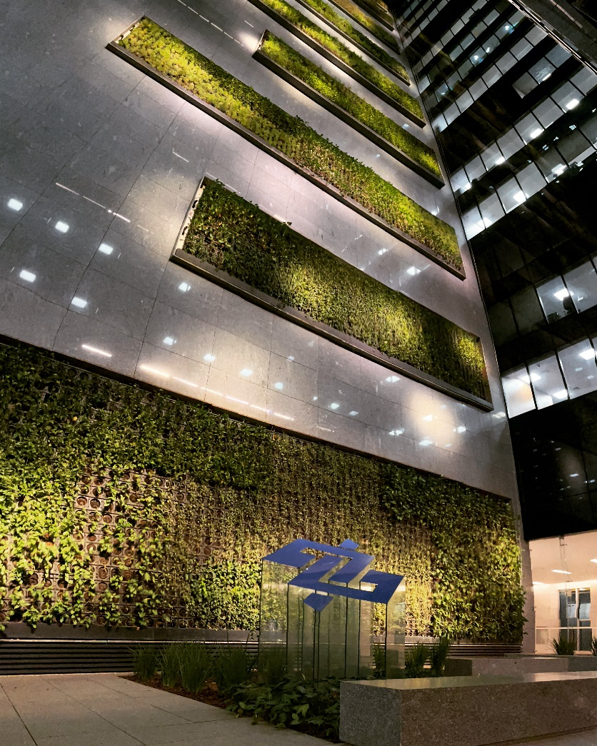
The main innovations in risk management and controls involve the development of automated tools for monitoring the internal control system and the main risks associated with the Institution's activities. Among these, the platform for real-time monitoring of compliance of products and services sold stands out, which reached more than 155 million verifications using innovative digital compliance technologies, analytics and artificial intelligence.
Another highlight of the period was the revision of the Compliance Program with the inclusion of the new advisor "Diversity, Equity and Inclusion – DE&I", in order to reinforce the commitment to promote diversity and combat any form of discrimination. Ethical aspects in the use of Artificial Intelligence technologies were also included.
Within the scope of the Customer and User Relationship Policy, we present the analytical model for complaints with potential judicial litigation for the preventive offer of solutions in the network itself or out-of-court settlement.
The resolution rate increased from 17.6% in January to 37.5% in July, while the reopening of the complaint fell from 16% to 4.6%. Satisfaction went from 2.1 (January) to 3.1 (July), on a score of 1 to 5. We also developed a panel to monitor complaints related to the context of diversity in order to address timely solutions to improve the experience of customers and users.
We invest in disseminating the statements of the Customer Policy in an easy and tangible way for our employees. We disclose, for example, the functionalities and importance of the “Minhas Finanças” tool, aimed at engaging in the management of finances and reducing risk indebtedness.
We assess risks and controls with a specific approach to mitigating greenwashing in related entities. In addition, we improved compliance testing for the Sustainable Business Portfolio through the use of automated solutions, reaching more than 395 thousand operations evaluated.
Further information on BB's risk management can be found in the Risk Management Report (Pillar III), in the Reference Form and in the Risk and Capital Management Policy available on the Investor Relations website (bb.com.br/ri).
Social, Environmental and Climate Risks and Opportunities
In June, we published the first Social, Environmental and Climate Risks and Opportunities (GRSAC) report, available on our Investor Relations website.
The GRSAC report is in line with the recommendations of the Task Force on Climate-related Financial Disclosures (TCFD), a global initiative aimed at improving transparency in the disclosure of climate-related financial information, which the Bank joined in May 2021. This is an important milestone in the sustainability agenda for the financial sector, as it raises the quality of financial information related to social, environmental and climate issues, and reinforces the agenda of ESG commitments and goals.
Finally, we continue to invest in initiatives to mitigate social, environmental and climate risks, in line with the commitments made in the sustainability agenda.

Independent Audit
In the contracting of services not related to external auditing, and in order to avoid conflicts of interest, loss of independence or objectivity of independent auditors, we adopt procedures based on applicable laws and standards and the best internationally accepted principles related to the subject. These principles are as follows: (i) the auditor shall not audit his or her own work, (ii) the auditor shall not perform managerial functions in his or her client, and (iii) the auditor shall not promote the client's interests. In addition, at Banco do Brasil, the contracting of services related to external auditing must be preceded by the opinion of the Audit Committee.
We hereby inform you that Deloitte Touche Tohmatsu Auditores Independentes Ltda. has not provided services that could affect its independence, ratified through the adherence of its professionals to the pertinent ethical and independence standards, so that they meet or exceed the standards established by the International Federation of Accountants (IFAC), the Federal Accounting Council (CFC), the Brazilian Securities and Exchange Commission (CVM), Central Bank of Brazil (Bacen), Superintendence of Private Insurance (Susep), National Superintendence of Complementary Pension Funds (Previc) and other regulatory agencies. These policies and procedures, which cover areas such as personal independence, post-employment relations, staff rotation, as well as the approval of audit and other services, are subject to constant monitoring.
Securities and Information of Affiliates and Subsidiaries
In accordance with article 8 of Bacen Circular No. 3,068/2001, we affirm our intention and financial capacity to hold, until maturity, the securities classified in the "Securities Held to Maturity" category. Our financial capacity is supported by cash flow projections that do not consider the possibility of selling these securities. The opening of securities by category and the reclassification of securities can be consulted in the explanatory note 10 – Securities. The amounts referring to unrealized gains and losses in the period, related to securities, are disclosed in Note 30 – Risk and Capital Management.
In compliance with article 243 of Law 6,404/1976, we hereby inform you that the company's investments in affiliated and controlled companies are listed in explanatory notes 2 – Presentation of Financial Statements and 14 – Investments.
Additional Clarifications
We have R$1.2 billion (individual and consolidated) of non-activated tax credits, presented in Note 22 - Taxes on Individual and Consolidated Financial Statements (sub-item "f").
In accordance with the rules set forth in the Financial Institutions Accounting Plan (Cosif), we recorded in clearing accounts the amount of R$17.9 billion arising from co-obligations and risks in guarantees provided to clients and companies that are members of the Banco do Brasil Conglomerate.
We annually publish the investments made because of the exercise of public policies in our Annual Letter of Public Policies and Corporate Governance, available on our website (ri.bb.com.br).
Banco do Brasil, its shareholders, management and the members of the Fiscal Council undertake to resolve any and all disputes or controversies related to the Novo Mercado Listing Regulations through the B3 Market Arbitration Chamber, in accordance with the arbitration clause contained in Banco do Brasil's Bylaws.
This Management Report was prepared based on the Individual and Consolidated Financial Statements prepared in the Accounting Standard of Institutions Regulated by the Central Bank of Brazil (Cosif)
For more information, the Reference Form, the Performance Review report, and the Institutional Presentation are available on the Investor Relations website (ri.bb.com.br).

