

Management
Report

1H25

Management Report | 1H25

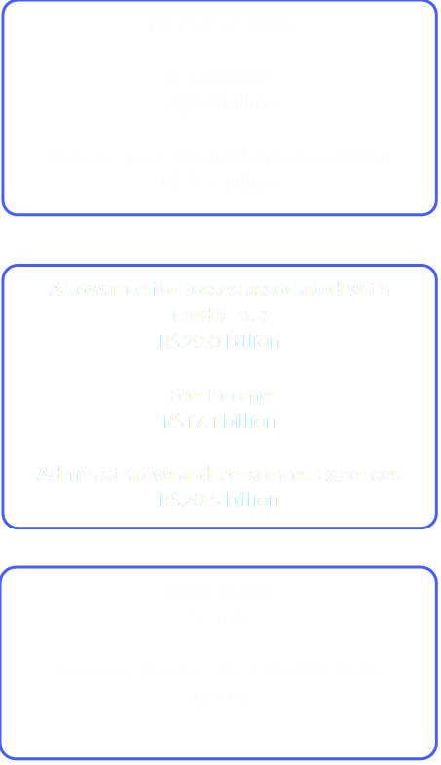
In June 2025, our assets reached R$2.4 trillion. The credit portfolio exceeded R$1.2 trillion, with growth across all segments, while customer funds totaled R$880.4 billion.
The income from financial intermediation was impacted by increased funding expenses due to the higher volume of deposits and the increase in the average Selic rate and the reference rate, partially offset by the growth in the credit portfolio which boosted revenues.
Influenced by the new loan creation dynamics following the adoption of Resolution 4,966/21, expected losses primarily reflected increased defaults in the agribusiness portfolio and, to a lesser extent, in the Micro, Small, and Medium- Sized Enterprises portfolio. Considering this, we took immediate action, including reviewing collection flows, prioritizing disbursements within the context of the resilience matrix, increasing credit lines with mitigating factors or guarantee funds, and strengthening our increasingly close and resolute relationships with clients.
In Fee Income, the highlights were the fund administration, consortium, and commission lines for insurance, pension, and capitalization, which already represent 56.8% of the total, demonstrating the complementarity of the portfolio with BB Asset, BB Consórcios, and BB Seguridade.
Administrative Expenses, in turn, showed growth consistent with operations, aligned with increased employee salaries and investments in technology.
As a result, net income for the first half of the year was R$9.8 billion, and the bank delivered R$28.4 billion in added value, considering taxes, salaries, dividends, and other components.
BB is a solid and resilient bank with over 200 years of history. We know that 2025 will be a year of adjustment. More than just short-term solutions, we are reinforcing the foundations for a sustainable future and consistent value generation for all our stakeholders.

Beginning in January 2025, the results began to incorporate the changes introduced by CMN Resolution 4,966/2021, which altered the accounting method for financial assets and the measurement of expected losses. The comparisons in this document consider the regulations in effect at the time of publication, without retroactively applying the data to 2024. To learn more about the main changes between the standards, see the Financial Statements.

The main highlights of the period

Worker Credit
In June, we surpassed the R$4.5 billion mark in Worker Credit, with more than 433,000 operations in 5,094 Brazilian municipalities since its launch in March of this year. With an analytics platform that integrates a broad set of data and information on relationships with companies and workers, BB offers personalized, secure, and efficient credit solutions, reinforcing its commitment to an increasingly inclusive and customer-centric approach.

2025/2026 Harvest Plan
We announced the allocation of R$230 billion to the segment. Of this total, R$54 billion will be allocated to small and medium-sized producers, while R$106 billion will serve corporate agriculture, including large producers, cooperatives, and agribusinesses. The assumptions for disbursements under the new Harvest Plan were based on external scenarios, such as climate, productivity, debt, and producer margins, and internal scenarios, such as liabilities, credit risk analysis, and collateral requirements with greater effectiveness in financing returns.

Disbursements with PEAC FGI and Pronampe exceeded R$30 billion
Considering the improved risk-return conditions, credit disbursements to micro, small, and medium- sized enterprises using guarantee funds (PEAC FGI and Pronampe) reached over R$30 billion in June 2025. Furthermore, we have been working within
the context of the resilience matrix and expanding operations with receivables and guarantees.

Changes in Collection and Recovery Structures and Practices
Seeking to achieve better results in collection and credit recovery processes, especially in rural and corporate operations, we have made improvements to our structures and procedures, aiming for more personalized, timely, and effective service, whether for debt resolution through renegotiations or for the execution of contractual guarantees.

BB in the Central Bank of Brazil Complaints Ranking
We have completed 12 consecutive quarters in the top position among the five largest banks within financial conglomerates, reinforcing our commitment to excellence in customer relationships.

The Most Sustainable Bank on the Planet for the 6th Time
We were once again recognized as the Most Sustainable Bank on the Planet in Corporate Knights' Global 100 ranking of the 100 Most Sustainable Corporations in the World 2025. Factors such as financial results, the size of our sustainable credit portfolio, carbon offsetting, the use of clean energy, governance practices, and the diversity of our workforce contributed to our ranking of 17th overall and our continued leadership among banks six times in the last decade.

AI- powered solutions for companies generates over 60 million recommendations
A year ago, we launched ARI – Intelligent Recommendations Area, which uses Generative AI to help manage micro and small businesses. More than 60 million personalized recommendations have already been generated, benefiting 2.6

Generative AI in the personal financial manager
Minhas Finanças Multibanco, our financial management tool, now uses generative AI to create personalized tips, assisting more than seven million individual customers monthly. These tips undergo a human curation process, ensuring message quality and mitigating unwanted biases. The tips are presented according to different contexts and customer financial profiles, addressing, for example, the best way to use credit or even suggesting data sharing via Open Finance to provide even more advantageous business conditions.

CRM with analytical intelligence
We have advanced our CRM operations with analytical intelligence, automation, and agility, connecting customer needs with the most appropriate solutions across all channels. In 1H25, we implemented over a thousand new personalized offering actions, generating 1.6 billion targeted interactions and 145 million effective customer contacts.
million businesses across the country. The insights translate complex data into practical, accessible guidance, curated by humans to ensure security and relevance.
The tool is available on the PJ Panel (web), BB Digital PJ, and the BB PJ app. In 2Q25, it recorded 23,000 unique visits via mobile, and the PJ Panel's NPS reached 83.66, one of the highest in the category.

Female Entrepreneurship
We reaffirm our commitment to gender equality and female entrepreneurship. In 2Q25, we disbursed R$294.6 million in exclusive credit lines for women, such as GIRO and FCO Mulher Empreendedora (Women Entrepreneur Credit Line), benefiting more than 1.3 million women-led businesses.
In Foreign Trade, we promoted the international integration of female SMEs. The First Export – Women in the World Edition program had trained 550 female entrepreneurs by June 2025, who are already exporting to more than 50 countries.

BB Cofrinho
In addition to our financial education solutions, in May 2025 we made BB Cofrinho, our financial reserve building tool, available to all individual customers. Through the BB app, you can create goals, track your financial progress, and customize each objective in a simple, intuitive, and secure way. The solution, launched in 2024 initially for exclusive use by young people, closed the semester with more than 90 thousand customers, with 65% of customers younger than 40 years old, and the investment volume exceeding R$145 million.

Shareholders
We have a base of 1.6 million shareholders, 99.0% of whom are local individuals. At the end of June, our shareholding structure was divided between 50% federally held shares, 49.6% free float, and 0.4% treasury shares. Of the total shares, 77.6% are held by local investors and 22.4% by investors residing abroad. Our shares (BBAS3) represented 2.55% of the Ibovespa index in the last four months. On the last trading day of June, BBAS3 was quoted at R$22.09.

Strategy and Corporate Governance

(Cosem); the Executive Board; and the Board of Directors.

The Corporate Strategy (ECBB) is the document that reflects the essence of our company, our vision for the future, and our desired destination. It is the result of the choices and sacrifices we make to strategically position BB in the face of market scenarios and challenges. Based on this positioning, we assess our capabilities and needs and define our actions through a structured, participatory process using established methodologies.
Although the ECBB's timeframe is five years, it is reviewed annually. In the last review, for the 2025- 2029 cycle, we ratified our purpose and values and reinforced our commitment to generating value for our customers, shareholders, and society, with a focus on social and environmental responsibility, digital transformation, and innovation.
Our BB Way is unique; it is what drives and guides us, and it is present in each of our employees and collaborators, who enable us to achieve our goals. Therefore, promoting continuous learning and an increasingly safe and inclusive environment is part of our culture.
The Board of Directors has at least 30% independent members, in compliance with the Bylaws, legislation, and the B3 Novo Mercado Regulations.
The Annual and Extraordinary General Meetings were held on April 30th, approving the Management's accounts and Financial Statements for 2024, as well as the allocation of net profit and the respective distribution of dividends; was elected and the overall annual compensation for Management, Board, and Committee members was established. Furthermore, a revision of the Bylaws was approved.

Our governance structure is comprised of the General Shareholders' Meeting; the Board of Directors (CA) and its advisory committees – the Audit Committee (Coaud); the People, Eligibility, Succession, and Compensation Committee (Corem); The Risk and Capital Committee (Coris), the Technology and Innovation Committee (Cotei), and the Corporate Sustainability Committee
Also in 2Q25, we prepared a comprehensive update of the Internal Regulations of the management bodies (Board of Directors, Board of Directors, and Executive Board) and the advisory committees to the Board of Directors, aiming to align them with best corporate governance practices and applicable standards.
Finally, in 2Q25, the Board of Directors approved the Annual Charter of Public Policies and Corporate Governance, unified for the Prudential Conglomerate (CPBB), including the Brazilian- based Affiliated Entities that comprise CPBB and have expressed their support for the unified Annual Charter. The aforementioned documents are available on the website https://ri.bb.com.br/ > Governance and Sustainability tab.

Technology that Transforms

Our Digital Strategy focuses on digital and cultural transformation, with constant innovation, cutting- edge technology, new business models, and greater agility to delight customers.
The strategic application of data and Artificial Intelligence (AI) has generated significant results: increased operational efficiency, business momentum, and personalized experiences. One example is the "Potential Carbon Credit – Low Carbon Agriculture" solution, which identifies properties with the highest retention of greenhouse gases. Recognized by the MapBiomas Award in July 2025, the solution generates five statistical indexes that optimize customer prospecting.
AI is also present in personalized investment offers, aligned with customer suitability profiles, with over R$260 million contracted.
In the payments field, BB Pay allows you to receive payments by contactless contact directly in the BB App, with the Tap on Phone function, transforming your cell phone into a terminal. In the first half of the year, the solution handled R$7.8 billion in 8.9 million payments, demonstrating growing adoption.
We also innovated by launching our own Banking as a Service (BBaaS) brand, BB com Serviço, with over
30 solutions in payments, credit, insurance, and consultations.
We enable businesses and promote financial education. With Open Finance, for example, we
reached three million customers with active consent, a 17% increase compared to 1H24, and surpassed R$2 billion in credit portability, with 57,000 customers transferring their transactions to BB.
In 1H25, we handled over 920,000 calls through the Minha Privacidade center, a personal data service channel, 95% of which were made via the BB app. The improvements implemented have improved the quality of the digital experience, with faster and more secure interactions.
Furthermore, we maintained an excellent rating for the BB App (4.7 on Google Play and 4.8 on the Apple Store), reaching 27.2 million users in 2Q25. And the BB Investimentos App, dedicated to investor clients, achieved a rating of 4.6 on both the Apple Store and Google Play.
Today, 94% of transactions are conducted through digital channels.
We are attentive to the future and to market developments. We have a Technology Trends Radar, available at bb.com.br/tendencias, through which we monitor trends and technologies, experimenting with and adopting those that are relevant.
To ensure organic growth and business continuity, we continue to invest in technology: R$3.2 billion in 1H25, reinforcing our commitment to an excellent digital experience—wherever, whenever, and however customers want it.

ESG ( Environmental, Social and Governance) Agenda

We are a benchmark in Environmental, Social, and Governance (ESG) practices, with risk and opportunity management initiatives. Our Sustainability Plan - BB Agenda 30, aligned with the UN SDGs and the Paris Agreement, is our main instrument, including 47 actions and 100 indicators for 2023-2025. Furthermore, the BB 2030 Commitments for a More Sustainable World establish objectives on four fronts: sustainable credit, responsible investment, ESG and climate management, aiming to generate positive impacts across the value chain.

Sustainable Funding
We raised R$39.8 billion for investments in ESG initiatives. The funds were obtained through the issuance of ESG-profile bonds, in addition to funding from multilateral institutions, investment banks, and international commercial banks. As a highlight for June 2025, we completed a new fundraising agreement called the SmartClimate- Smart Agriculture Repurchase Agreement with Banco Natixis, worth US$100 million. The objective is to promote sustainable agriculture while ensuring support for responsible production.
We highlight the initial releases of funds from the first auction of the blended finance subline of the ecoinvest program, an initiative that combines public and private capital to foster sustainable
projects in the country. The initiative is expected to generate R$4.8 billion in new sustainable operations, leveraging the funds raised and generating a significant real-world impact through the sustainable themes addressed by the program.
We are a key player in the execution of sustainable investments in Brazil, applying sustainability through our published framework.
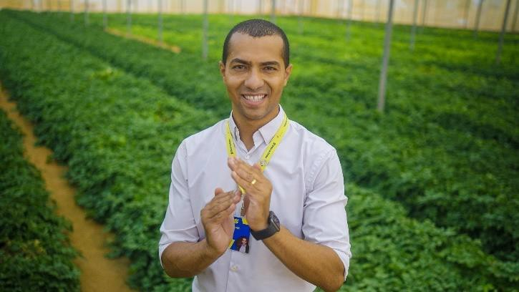

Bioeconomy and Value Chain
We have contributed to the development of biodiversity in the country by providing financial resources, specialized services, credit lines with attractive terms, and financial consulting services to assist quilombola family farmers and indigenous peoples working in the bioeconomy. We are currently one of the leading financiers of forest- friendly products, with R$1.9 billion in bioeconomy and value chain projects in Legal Amazon, representing 39% growth in the last 12 months.

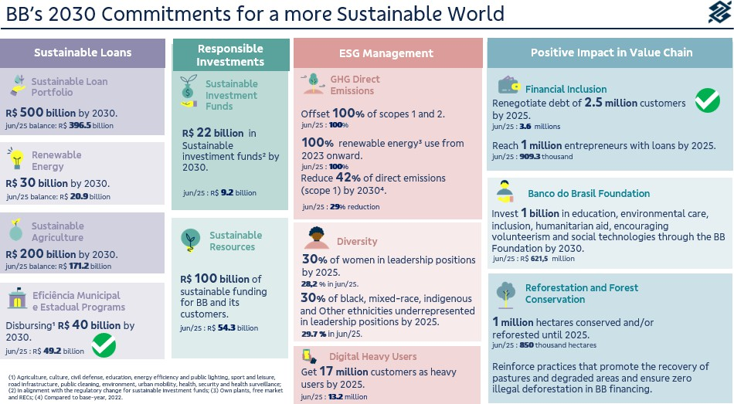

Sustainable Business
In 2Q25, the sustainable credit portfolio reached R$396.5 billion, a 10.6% increase over 12 months, reflecting our commitment to the transition to a more sustainable economy. The funds were allocated to sectors with positive socio- environmental impacts, such as renewable energy, sustainable agriculture, healthcare, and education.
The Sustainable Credit Portfolio undergoes independent assessment based on national and international ESG taxonomies. The methodology is continually updated to incorporate best practices and include new products with ESG attributes.

Carbon Market
We strengthened our presence in the voluntary carbon market, supporting clients in the creation of projects with high environmental additionality, GHG emissions inventories, decarbonization plans, and the offering of carbon credits to offset unmitigated emissions. We also facilitate

intermediation between credit buyers and sellers and offer specific lines of credit for renewable energy and energy efficiency projects.
By June 2025, more than 850,000 hectares had been preserved or reforested through carbon projects and credit operations. Forest conservation projects (REDD+) combine environmental preservation with income generation.
To diversify credit generation, BB launched the Biogas Program in June 2024, focused on biogas and biomethane production in agriculture.
Towards COP30, BB is also strengthening decarbonization with the issuance of more than R$729 million in CPRs backed by Decarbonization Credits (CBIOs), encouraging biofuel production and participation in the RenovaBio program, which contributes to Brazil's energy security and climate commitments.

Diversity, Equity, and Inclusion

We remain committed to diversity. Currently, women represent 44% of the Board of Directors (BD) and 50% of the Board of Directors (BD). Additionally, two members of both the Board and the Board of Directors identify as Black. Two members of the Board and one member of the Board identify as LGBTQIAPN+. Finally, the Board also includes one member who self-identifies as a person with a disability (PWD).
In April, we held discussions with Indigenous leaders about the preservation of territories and culture, resulting in proposals for partnerships and joint actions. Initiatives with the Kayapó people were discussed in the areas of carbon credits, family farming, restoration of degraded areas, credit, social technologies, and sustainable projects.
In May, we announced a partnership with LinkedIn to strengthen the Women at the Top program, expanding its reach and further promoting female empowerment. The Women at the Top Showcase on LinkedIn was developed as a hub for exclusive content, inspiring podcasts, posts from Top Voice women, career tips, training trails, articles and data on the economy and market, real stories, and opportunities.
In June, our president, Tarciana Medeiros, participated as a speaker at Tempo de Mulher, the first Brazilian network that supports and connects top female executives and C-level leaders and
entrepreneurs in the country. Now in its 5th edition, the event seeks to foster an environment of exchange and inspiration, where women can share their professional trajectories, management strategies, and safe paths to growth within the corporate market.
Also in June, we supported Inovahack MBM São Paulo, an event created by the Black Money Movement, focusing on technological solutions with social impact for peripheral communities. The event promoted dialogue between leaders and entrepreneurs, with the theme "Peripheries in Focus: Innovation for Transformation," aiming at the economic empowerment of Black communities. During the same period, we participated in another edition of the LGBT+ Diversity Cultural Fair, held at the Memorial da América Latina in São Paulo. This event reaffirmed our commitment to equity, inclusion, and sustainable development, promoting initiatives focused on entrepreneurship and professional development for the LGBTQIAPN+ community.
The BB Foundation and Distrito Drag officially launched the Empregando Orgulho platform (empregandoorgulho.com.br), an initiative focused on employability, entrepreneurship, and economic inclusion for the LGBTQIA+ community in the Federal District.

Major Awards and Recognition

March
We received two awards at Agile Trends 2025, one of the largest agility and innovation events in the country. The two recognized cases demonstrate significant advances in automation, agile culture, and digital transformation: Agiliza – Automation and Self-Healing Portal; and Movimento Aceleração Digital – Creation and implementation of an agile framework in a 216-year-old bank.
We were recognized in three categories at the AI in Finance 2025 Awards, promoted by Global Finance magazine, which highlights the most innovative financial institutions in the use of artificial intelligence:

- CONSUMER BANKING: | Best | Banks | by
Country – Brazil;
- CORPORATE BANKING: | Best | Banks | by
Country – Brazil;
- CORPORATE BANKING: | Best | Banks | by
Region – Latin America.
We were recognized in the Innovation category of the 100+ Innovators in the Use of IT 2025 award, promoted by the IT Forum, with the Pix por Aproximação case study.
We were one of the winners of the Celent Model Bank Award 2025, receiving recognition in the "AI Innovation for Small Business" category for our use of Generative Artificial Intelligence to offer personalized account insights to micro and small businesses through the ARI (Intelligent Recommendations Area). This award joins two others: Global Finance – The Innovators (Latin America) and AI in Finance Awards in the Enhanced Customer Experience and Personalized Financial Advice categories.
BB Private was recognized as the best private bank in the country for sustainability at the Euromoney Private Banking Awards 2025, organized by the renowned specialized publication Euromoney. This is another unprecedented recognition for BB Private, embodying our commitment to actions that strengthen sustainability in our business.

April
We received the award for Best Public Institution of the Year during the II Social PPP Forum, presented by the PSP Hub – Infrastructure and Urbanism Studies research center and Hiria Nurnbergmesse Business. The award recognizes BB's leading role in strengthening the Public-Private Partnership (PPP) and concessions ecosystem.

May
At the BNDES 2025 Recognition Awards, we were recognized in the "Finame 60 Years" and "Business Highlight" categories for our performance in disbursing credit lines using resources from the development bank. The event brought together the country's leading financial institutions.
For the second consecutive year, we were recognized for the work of our legal director Lucinéia Possar, winner of The Latin American Lawyer Women Awards, in the In-House Counsel of the Year Banking & Finance category.

June
We received our 11th Broadcast Analysts Award, reaffirming our prominent position in the financial market.

Independent Audit
BB strictly follows all applicable laws and regulations for independent auditing, ensuring transparency and compliance in its processes. KPMG Auditores Independentes Ltda. is the company contracted to provide external audit services for the financial statements.
Regarding the non-audit services it provides within BB, they do not represent a conflict of interest nor do they compromise its independence in the execution of its work. Information on fees for non- audit services is disclosed annually in our Reference Form, in accordance with CVM Resolution 162/2022.

Additional
Clarifications
We have R$1.1 billion (consolidated) in unused tax credits, presented in explanatory note 22 - Taxes (subitem "f"). In compliance with Article 243 of Law 6,404/1976, we hereby inform you that the company's investments in affiliated and controlled companies are listed in the explanatory notes
2 – Presentation of Financial Statements and 14 – Investments.
We publish annually the investments made in public policies in our Annual Public Policy and Corporate Governance Letter, available at ri.bb.com.br.
Banco do Brasil, its shareholders, directors, and members of the Fiscal Council undertake to resolve any and all disputes or controversies related to the Novo Mercado Regulation through the B3 Arbitration Chamber, in accordance with the arbitration clause contained in Banco do Brasil's Bylaws.
This Management Report was prepared based on the Individual and Consolidated Financial
Statements prepared in accordance with the Accounting Standards for Institutions Regulated by the Central Bank of Brazil (COSIF). For more information, the Reference Form, Performance Analysis Report, and Institutional Presentation are available at ri.bb.com.br.

Acknowledgements
We deeply thank all our employees who demonstrate commitment, dedication, and capacity for innovation every day. Their commitment to adapting, creating, and improving solutions and maintaining a focus on excellent relationships with our customers is essential to achieving our purpose. We also extend our gratitude to our customers and shareholders, whose trust is fundamental. We reinforce our commitment to generating value sustainably, balancing consistent results with social, environmental, and ethical responsibility in all our actions.

