Dear reader,

In 2023, we recorded net profit of R$33.8 billion, an increase of 8.7% compared to 2022. We renewed our record of generating robust results, based on sustainability in generating business and relationships with our customers.
In addition to a strong result that remunerates shareholders and supports credit growth, we reached R$86.1 billion in value added to society, when we consider taxes, salaries, dividends, and other components, which represents an increase of 7.3% in a year.

The classified portfolio reached R$975.3 billion, because of the relationship we have with our customers and the quality of solutions offered in a personalized way for all segments. The sustainable business portfolio reached R$343.1 billion, an increase of 4.8% compared to December/2022. This total represents 35.2% of our classified loan portfolio. Of these resources, R$66.1 billion is allocated to low-carbon agriculture and R$55.8 billion to Pronaf, which supports family farming.
In recognition of our contribution to a more sustainable economy, we are once again classified as the most sustainable bank on the planet in the ranking of the 100 Most Sustainable Corporations in the World 2024 – Global 100, by Corporate Knights. In 2024, in addition to its leadership position among banks, BB is the only Brazilian company classified. In the last decade, we were listed in eight editions, being recognized as the most sustainable bank in the world in five of them (2019, 2021, 2022, 2023 and 2024).

We expanded our portfolio of products that bring positive social, environmental and climate externalities. Among them, we began to operate in the carbon market, combining financial viability with forest preservation. We launched the first ETF (Exchange Traded Fund) in Brazil with a Diversity theme, signed a protocol of intentions to materialize our first credit operation with clients linked to environmental performance (sustainability-linked loan) and sought partnerships to operate in the value chain of bioeconomy in the Amazon region. Furthermore, we raise funds on the international market in order to finance the growth of sustainable credit operations.
We maintain our commitment to diversity, equity and inclusion and as a result, we were selected to be part of the first Latin American index that measures gender and race criteria in Brazilian companies listed on the stock exchange (iDiversa from B3), being in the best position between financial companies. This year, we increased the participation of female leaders in senior leadership positions, totaling 44% of the Board of Officers and 50% of the Board of Directors, which was recognized during the 2023 Sustainable Congress of the CEBDS (Brazilian Business Council for Sustainable Development).
We reaffirm our commitment to micro and small businesses. At Pronampe, we reached more than R$34.5 billion in portfolio balance in December/2023, with operations with around 322 thousand Micro and Small Enterprises (SME). We have advanced in offering digital solutions to SME with the PJ Panel, a multi-service online platform that unifies and presents, in an Open Finance view, all the relevant commercial and financial information of these clients. Another highlight was the growth of the Large Companies portfolio, which ended December/23 with a balance of R$213.7 billion, compared to R$197.8 billion in September/23.
We also increased our proximity to the public sector, totaling more than R$59.6 billion in credit for states and municipalities, growth of 11.9% compared to 2022.
In agribusiness and family farming, we maintained our historical position as the main financial agent in the country, contributing significantly to meeting the credit demand of the segment and its chain. With this, we reached a classified credit portfolio of R$320.2 billion. In July/2023 we announced the largest Harvest Plan in our history, allocating R$240 billion, of which R$120.1 billion has already been disbursed, an increase of 5.4% over the same period of the last harvest. Highlights include the hiring of the National Program for Strengthening Family Farming (Pronaf) and the National Support Program for Medium Rural Producers (Pronamp). There were 371 thousand operations contracted in the 2023/2024 Harvest Plan, in more than 4.9 thousand municipalities.
In the Individuals segment, we highlight the 9.8% growth in the payroll loan portfolio, which reached R$126.4 billion, reflecting the close and specialized service to our more than ten millioncustomers that receive their salaries with us.
With the aim of being increasingly connected with new generations, we celebrated the first year of BB Cash, our digital account for teenagers, which can now be used by customers aged 10 and over. We also made the “My Missions” solution available on the BB App, with which we support young people aged 18 to 25 on their financial journey through gamification, in addition to offering financial education via social networks to this audience.
We invested in digital acceleration to be an even closer, more complete and available bank for our more than 83 million customers. As a result, they have available, on our integrated channel platform, solutions suited to their profile and moment in life.
We highlight that this year our customer satisfaction increased, which was reflected in our best position in the ranking of complaints at the Central Bank in December.
We advanced in cultural transformation. We have evolved in the operational working model of our teams, which has become increasingly agile. We hired more than 800 IT professionals and invested in training focused on digital skills. We have grown in our internal innovation practices with experimentation laboratories for new technologies. Also, we developed data and analytics solutions, in addition to partnerships with fintechs and startups that co-create with us.
Net Income
R$33.8 billion
Growth of 8.7% compared to 2022
In the year 2024, we renew our commitment to continue delivering sustainable results for our shareholders, adding value to society and fulfilling our purpose of being close and relevant in people's lives, at all times, thus contributing to the development of Brazil. We invite you to learn more about our initiatives on the following pages.
Good reading!

Consolidated Financial Statements Results
Added Value
R$86.1 billion
Growth of 7,3%
compared to 2022

The net profit of R$33.8 billion in 2023 was a reflection of the good commercial performance in the various lines of business, especially in the offer of credit with quality, the diversification of products and services and the discipline in cost management.
Our classified credit portfolio reached R$975.3 billion, growth of 9.4% compared to December/22. The Individuals loan book, disregarding rural producers, grew 7.9% with emphasis on payroll loans. The Corporate portfolio, without agricultural companies, grew 9.7%, with emphasis on the balance with Large Corporate clients, which increased R$117.2 billion. Credit operations with producers and agricultural companies grew by 12% in the same period.

The Basel Index reached 15.47% and the Core Capital Index ended December at 12.12%.
To find out more details about the profit and loss and balance sheet items for the period, please see the Explanatory Notes contained in the Financial Statements and the MD&A Report.

 | Banco do Brasil |  | BB Consolidated
Earnings (R$ million) | 2023 | 2022 | 2023 | 2022
Net Income | 33,615 | 30,898 | 33,819 | 31,112
Income from Financial Intermediation | 53,436 | 50,054 | 65,707 | 57,669
Fee Income | 21,066 | 20,537 | 33,831 | 32,333
Administrative and Personnel Expenses | (35,974) | (32,877) | (38,001) | (34,536)
Equity (R$ million) | Dez/23 | Dez/22 | Dez/23 | Dez/22
Assets | 2,208,054 | 2,062,967 | 2,172,480 | 2,029,399
Classified Loan Portfolio | 964,925 | 877,064 | 975,349 | 891,283
Resources from Customers | 787,539 | 722,516 | 811,944 | 753,263
Shareholders Equity | 163,638 | 153,839 | 173,076 | 164,029

Shareholders
We have a base of more than one million shareholders, 98.6% of which are individuals and 1.2% legal entities. At the end of December, our shareholding composition was distributed between 50% of shares held by the Federal Union, 49.6% in circulation (free float) and 0.4% held in treasury. Local investors held 73.7% of the shares, and foreigners held 26.3%. Our shares (BBAS3) represented 3.440% of the Ibovespa in the last four months. Banco do Brasil shares ended the last trading session of 2023 at their historic high, quoted at R$55.39, a growth of 59.44% in the year.
Shareholder Remuneration
The Shareholder Remuneration Policy seeks to guarantee due shareholder appreciation, combined with the Bank's longevity and financial sustainability in the short, medium and long term, with the premise of flexibility and financial solidity that ensure the sustainability of the business.
For the 2023 financial year, the distribution of dividends and/or Interest on Equity (IOC) corresponding to 40% of net profit was approved, adjusted as provided in letters “a” and “b” of item I of article 202 of the Law 6,404/76, based on the Bank's results, its financial condition, cash needs, the Capital Plan and its goals and respective projections, the Declaration of Appetite and Risk Tolerance, perspectives of present and potential markets, existing investment opportunities and the maintenance and expansion of operational capacity. The total amount allocated to shareholders in 2023 was R$13.0 billion and the value per share was R$4.566.

Corporate Strategy

Our Corporate Strategy (ECBB) has a time horizon of five years and is reviewed every year, through a structured, participatory process and using consolidated methodologies.
The latest review, focusing on the period 2024-2028, was approved in September 2023, establishing the following strategic objectives: (a) provide the best experience to customers at all times; (b) create value and generate sustainable results; (c) be a protagonist in sustainability and in the promotion of business and ESG practices; (d) evolve our way of working to accelerate digital transformation and innovation; and (e) have people engaged with BB's values and promoting collaboration, respect and inclusion.
The construction of ECBB 2024-2028 featured an innovative dynamics, with this edition being the most collaborative so far. The beginning of the process was built with the direct participation of employees from across the country. The contributions were significant. Our SWOT matrix, for example, was formulated based on more than seven thousand interactions received, with employees' perceptions about our Company, the challenges, opportunities and trends for the future.
In the refinement stage, members of the Executive Board, presidents of entities linked to BB, executives and a group of superintendents debated and jointly constructed the definition of indicators and key results for five perspectives: Customers, Financial, Sustainability, Transformation Digital and Processes and, People and Culture. In September, the ECBB was approved collectively, both by the Board of Officers and the Board of Directors.
Our purpose is “To be close and relevant in people’s lives at all times”. That is why we exist, to always be together, support and maintain close relationships with people, regardless of the channel. We are relevant because our greatest aspiration is to generate value and be essential in the lives of the people with whom we interact. We want this purpose to be present in our relationships at all times, as we offer complete solutions so that people can count on us during all phases of their personal and professional lives.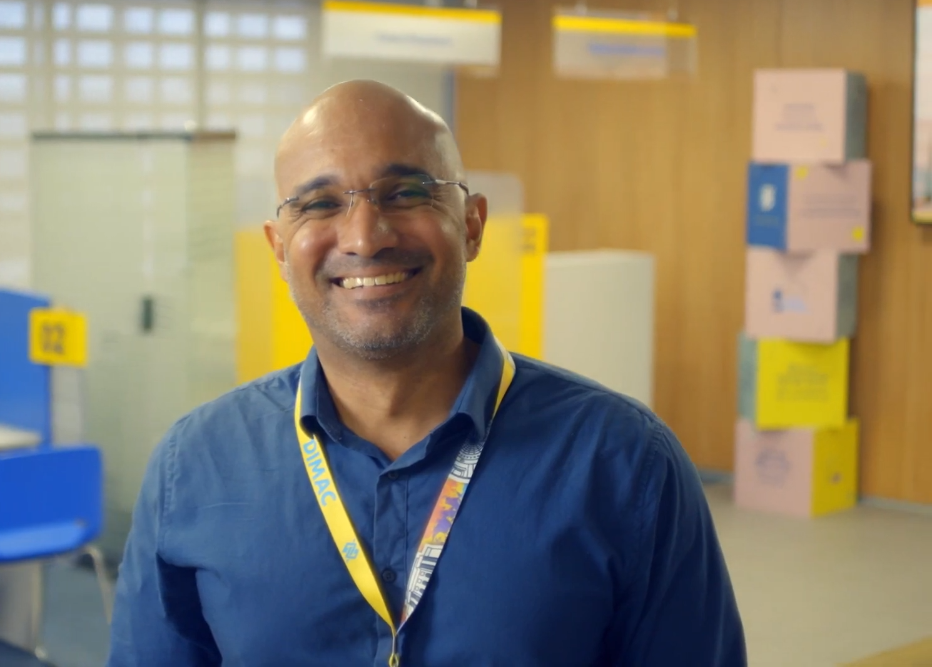
Aligned with our purpose and reinforcing the Company's organizational identity, we improved our values to make even clearer the unique principles that guide our operations and inspire our team's deliveries, with emphasis on the new value included: diversity. Thus, our values are: Proximity, Innovation, Integrity, Efficiency, Commitment to Society and Diversity.
The Strategic Map, composed of the Strategic Objectives and the Master Plan, outlines the strategic guidelines, indicators and respective goals for the next five years, distributed across the five perspectives. The customer is at the center of our operations and decisions at all organizational levels, receiving complete solutions and an appropriate experience. We are a competitive, profitable, efficient, innovative bank, a reference in sustainability and ESG business. All of this is the result of excellence in optimized capital allocation, high operational efficiency, a rational organizational structure, the development of new businesses and diversified revenue sources.
We accelerate digital transformation and innovation, using analytical intelligence and at the same time maintaining focus on improving models, processes, products and channels, with the aim of making them simpler, more agile and responsive, and thus creating a bank for each customer.

Clients

We look at our customers in a broad way, breaking traditional segmentation barriers and getting to know their interests, consumption habits, lifestyle, values and affinities. With the efficient use of data, we know and value what is important to each customer, promoting a close relationship that goes beyond core banking.
Applied analytical intelligence allows us to further personalize the relationship, generating good experiences and relevance, so that customers have access to a highly specialized Bank, with products, services and advice suited to their needs.
In recent years, there has been a significant evolution in the migration of transactions to digital channels. At the same time, human contact remains relevant, whether physically or remotely, for advice, conducting business and more complex demands. Complementarity is necessary for the experience to be fluid, both in digital self-service and in-person or remote service.

Active listening and understanding the needs of our customers are at the center of our actions. After each service provided, we send an evaluation survey to the customer and the grade received is linked to the evaluation of the employees' half-yearly performance, to ensure that the quality of service and customer satisfaction are a common objective for everyone. The consequence of constant monitoring of customer needs and satisfaction is reflected in the reduction of complaints to SAC (Customers Service), the BB Ombudsman and the better positioning in the Central Bank ranking.
Seeking to deliver a unique, integrated experience aligned with customers' goals and moments in life, in 2023 we acquired a market tool to improve the management of your CRM. With this, we open a range of new forms of relationships and engagement. We build smarter communication journeys, using Artificial Intelligence. We adopt more data-based decisions and exploration of the customer base to generate new business opportunities. The tool provides a 360º view of customers and allows a new level of data and information integration to generate value for them, in an omnichannel vision.
Still in 2023, we made changes to our internal structures with the aim of evolving our relationship model and delivering a better value proposition to our client. We are focused on hyper-personalization and retail transformation.
We continue to advance in migrating the service structure to lighter, more efficient and specialized models. As a result, we can offer a comprehensive experience across channels, expanding our reach and ensuring the best convenience for customers. BB enabled business and innovations to always be close and available to customers, whether they are in branches, on the App, on social networks or in the metaverse.
Our initiatives to improve the customer experience have shown positive results in terms of satisfaction, which has been reflected in our Net Promoter Score (NPS), which throughout 2023 showed an increase of more than 10% in the index compared to 4Q22.
We were among the three institutions with the lowest rate of complaints in the Central Bank Ranking in 4Q23 and became the first bank, among the four largest banks in the Country, to reduce the number of valid complaints to less than 500 in a quarter. Considering banks with more than 60 million customers, we had the lowest complaint rate in the period.
The Customer Council is a meeting dedicated to active listening in which representatives of Banco do Brasil Management and customers from all relationship models participate. The objective is to amplify the customer's voice at different levels of the Bank and bring it to the center of decision-making, to ensure continuous improvement of the relationship and better delivery of the Value Proposition for different customer profiles. In these initiatives, customers have the opportunity to share their perceptions, experiences and desires about Banco do Brasil's services and solutions.

Technology and Inovation

We are attentive to market movements and innovations, we monitor emerging trends and technologies, to improve our operations and accelerate our digital transformation.
We work with enabling platforms, through which we build Banco do Brasil's products and services. There are more than 20 platforms, including Analytics, Mobile, Artificial Intelligence, LowCode and Cloud. This management model allows us to accelerate and scale new technologies, standardize and provide greater quality to deliveries, positively impacting our ability to respond more quickly to market changes and to our customers' needs. With the Mobile Platform, for example, we reduced the delivery time for solutions on this track by 54% in the last two years.
This strategy is complementary to the continuous escalation of a more integrated work model between all areas of BB, which continues to expand, supported by our cultural transformation. In 2023, we welcomed more than 800 IT employees, from external selection, and we will continue to increase our number of technology professionals, reinforcing our commitment to being increasingly agile and focused on delivering more value to our customers and society.
We have one of the largest technology parks in Latin America and have invested in automation and expansion of our processing capacity, working to deliver an increasingly resilient environment. In 2023, we executed almost 4 trillion IT transactions that enabled major movements, such as Pix and Open Finance.
We adopt a hybrid multi-Cloud strategy, with market-leading providers, in addition to our private cloud. We increased the number of applications and services on this platform by 47% in the last year, resulting in greater flexibility and speed in delivering solutions to the customer and in the expansion of processing capacity without loss of performance and greater availability of resources. Solutions such as Pix, Open Finance, Chatbots and Fraud Monitoring are being implemented in this type of architecture.

There are more than 5,000 applications and services executing millions of operations per day.
We realize the value of data as a strategic asset and understand that the use of Analytical Intelligence contributes to deeper knowledge about the customer, to the development of new businesses and to the improvement and expansion of existing products and services.

Our analytical solutions form a robust ecosystem, adapting tools to user demands and incorporating the best market practices. In 2023, there were 333 billion customer interactions captured on digital channels, covering more than 25 million customers, with data processed in real time, a growth of 73% compared to 2022.
The use of Artificial Intelligence has been a reality at Banco do Brasil for some years, being part of the business, service and security processes. The chatbot on Whatsapp, “Minhas Finanças” and Crop Monitoring are some examples of tools that, using AI, guarantee the best experience for our customers and employees and contribute to operational efficiency. Furthermore, BB already has several internal Generative AI initiatives underway, being tested and evaluated, with the aim of leveraging the use of this technology.
We reached a record number of 22.9 million users on the App, which remains one of the best rated in the financial market (rating of 4.6 on Google Play, performed by more than 6.18 million users, and 4.7 on the App Store (Apple), with 2.95 million reviews), on a scale with a maximum score of five stars.
In December 2023, we surpassed 29.5 million active customers on digital platforms. Transactions carried out in these channels represented 93.0% of our customers' operations in 4Q23. On Whatsapp, there are 19.6 million users and in 2023 more than R$200 million in CDC disbursements were made on this channel. Furthermore, 30.9% of service operations (such as investment, card application, account opening and business with capitalization, insurance and consortiums) were carried out through digital platforms.
We continue to be in a prominent position as one of the most relevant actors in Open Finance in Brazil and abroad. We were the most awarded institution for the second consecutive year at the Open Summit Awards 2023, considered the biggest Open Finance event in Brazil.
In 4Q23, we reached the mark of R$3.4 billion in increases in credit limits for individuals based on information shared via Open Finance, an increase of 50% compared to the previous quarter. With new use cases for data shared with Banco do Brasil, new customers joining Open Finance continued at an accelerated pace. At the end of 2023, we had 11.1 million unique customers sharing data and more than three million consents.
In November/2023, BB Digital Week – BBDW was held - a technology, innovation, business and sustainability event that took place at the Ulysses Guimarães Convention Center, in Brasília. During the 3 days of the event, there were more than 13 thousand participants, of which 5,000 were from an audience outside BB, 70 lectures, 42 panels and 20 environments made up the event, which was positively evaluated with a score of 4.7, on a scale of 1 to 5, reinforcing our positioning as a technological and innovative company.
Recognition in Technology and Innovation
• "Bank of the Year 2023" – we were awarded as the best bank in Brazil this year. The event is organized by the Financial Times and is considered the “Oscars of the Financial Industry”. The award highlights the ability to present a strong financial performance and, at the same time, transform challenges into opportunities, in a competitive and constantly evolving business environment.
• Public Sector Innovation Award focused on citizens, recognized by the Brazilian Institute of Public Governance (IBGP), with the SisconDJ-WEB solution included in the State Companies Category. Through the Interconnection solution with the Courts of Justice and Regional Labor Courts, the entire process of payment of permits for beneficiaries is carried out directly by public servants and judges, without the intervention of the agency network.
• Awarded as the “Most Connected Bank in the Country” by Aberimest Brasil, at the opening of the Global Smart Summit 5G Tech. BB was awarded as the best in the Communications sector in Brazil for the project resulting from the partnership with Claro and Embratel – in partnership with the Network Platform – for the activation of 5G technology at BB, which is already available at the headquarters of the Bank in Brasilia. With this, BB took the lead and is the first public bank in the country to have 5G technology.
• Global Finance Award – The Innovators - Top Innovations in Finance 2023 – Marketing - Metaverse Brablox.
• Global Finance Award – Best Digital Bank - Best info Security & Fraud Management - Questionnaire with strategic information.
• Banking Transformation 2023 Award (Brazilian Catarino) – (i) Acceleration of implementation of solutions in digital channels (Operational Efficiency Category); (ii) Electronic notary registration in rural operations (Innovation with AI Category).
• At the Open Summit Awards, BB was the winner in the “Financial Institution (S1 and S2)” categories; “Credit use case” with the Personalization of Corporate Rates case with Open Finance data; and “Use case for Individuals”, with the “Minhas Finanças” case on WhatsApp.


ESG (Environmental, Social and Governance) Agenda
In 2023, we consolidated our best sustainability practices. We improved management, increased the sustainable business portfolio, expanded the offer of products with social and environmental characteristics and reinforced our internal structure that takes care of the ESG theme, emphasizing work on the topics of diversity, equity, inclusion, and sustainable business.

We updated the 12 Commitments for a More Sustainable World and became ambassadors for 3 movements of the UN Global Compact: Women Lead 2030, Race is a Priority and Living Wage.

We released the Sustainability Plan - Agenda 30 BB (2023-2025), which resulted in 47 actions and 100 indicators, already reflecting the premises of the global 2030 Agenda and the international call for the construction of a world guided by the adequate management of natural resources, respect for human rights and generation of value for society and the environment.
Our commitment to developing business solutions with social, environmental and climate aspects is guided and stated in our Social,
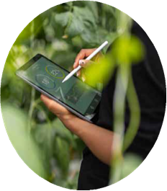
Environmental and Climate Change Policy (PRSAC) and based on the BB Sustainability Guidelines for Credit, which are in synergy with the international commitments assumed by the Federal Government, including those related to mitigation and adaptation to the effects of climate change. In 2024, sustainability will continue to be central to our brand and business.
BB 2030 Commitments for a + Sustainable World
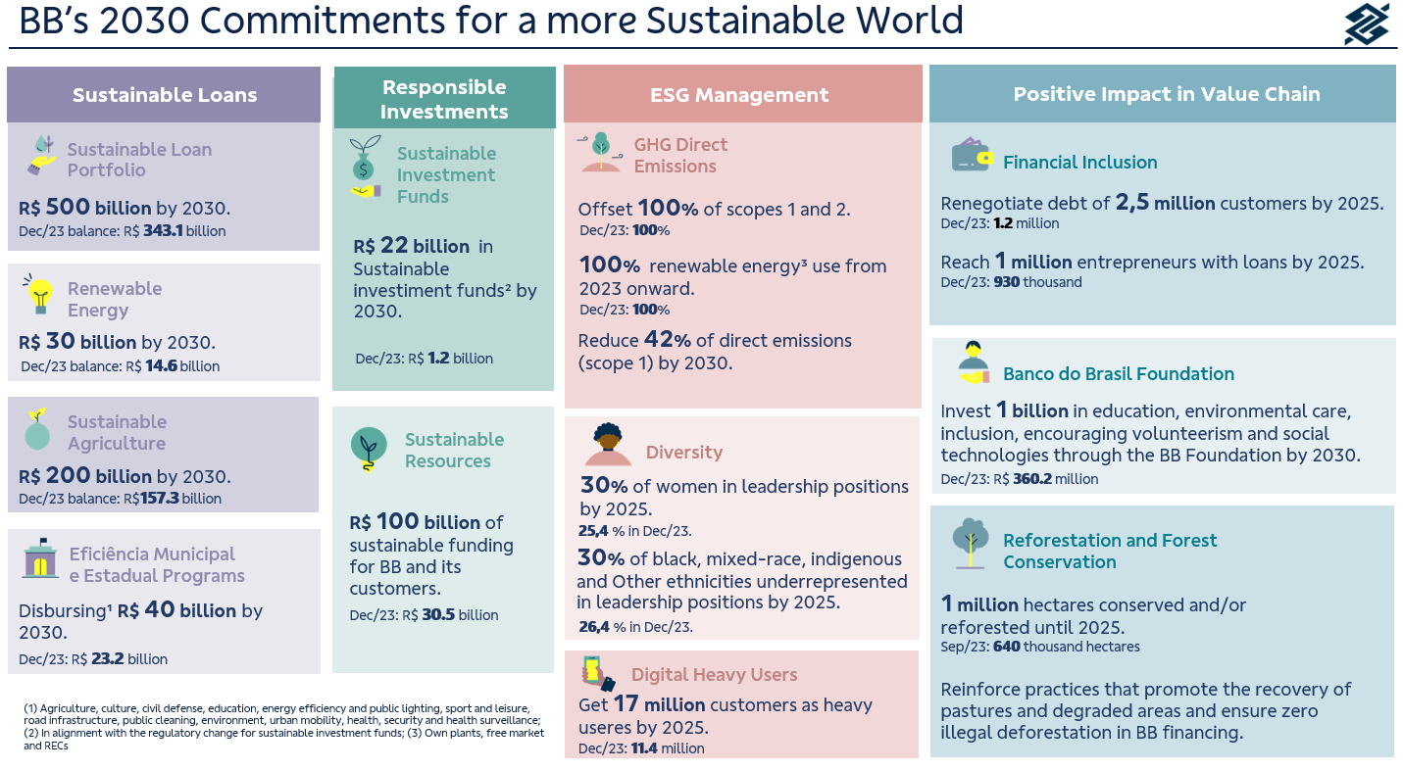
Updated in August, the BB 2030 Commitments for a sustainable future bring objectives on four fronts: (i) sustainable credit, (ii) responsible investment, (iii) ESG and climate management and (iv) positive impacts on the value chain. The goals defined are in line with the Sustainable Development Goals (SDGs) of the United Nations (UN) and make up our Sustainability Plan.
Compliance with sustainability indicators and goals is reflected in the remuneration of the entire workforce, including senior management, which ensures alignment between business, people and social, environmental and climate issues.
Sustainable Fundraising
In April 2023, we released the first Resource Allocation and Socio-Environmental Impact Report of the Social Bond issued by BB in January 2022. The document meets the premises of our Sustainable Finance framework and received the limited assurance opinion of the independent auditor.
Still in April, BB issued its second international bond within the scope of the Sustainable Finance framework. The international raising of senior debt, of the sustainability bond type, in the amount of US$750 million, matures on April 18, 2030 and has a coupon of 6.250% p.a. The resources raised will be allocated to renewable energy projects and financing micro and small businesses, especially those led by women.
In September 2023, Banco do Brasil and the Inter-American Development Bank (IDB) signed a letter of intent to facilitate a financing partnership worth US$250 million that is part of a Conditional Credit line for Investment Projects (CCLIP) with a global value of up to US$1 billion (resources from the IDB and the Green Climate Fund). The initiative aims to promote an inclusive and sustainable development model in the Amazon region, supporting companies and rural producers that are part of the bioeconomy value chains in the region.
Furthermore, we have advanced in cooperation with the World Bank (WB) aimed at the transition to a low-carbon economy and promoting projects to recover degraded areas in the Legal Amazon region. This front of action seeks to identify sustainable solutions for forest restoration and promotion of sustainable low-carbon agriculture, with a special geographic focus on the Legal Amazon region in support of the National Plan to Combat Deforestation in the Amazon (PPCDAM).
The objective is to identify and explore financial opportunities for technical assistance, together with other public and private partners at regional, state and national levels, in addition to developing value chains, increasing economic opportunities, maintaining biological, cultural and social diversity, as well as reducing greenhouse gas emissions.
During Climate Week in New York, Banco do Brasil and BMO Financial Group (BMO) signed a Memorandum of Understanding to grant Sustainability Linked Trade Loans for Advances on Foreign Exchange Contracts (“ACC”) and Advance on Foreign Exchange Delivered (“ACE”), with an emphasis on exporting products from sustainable production and agriculture systems.

The new operation, unprecedented in the Brazilian market, seeks to encourage the export chain of sustainable and Brazilian products, encouraging better trade finance practices and supporting the supply of certified and quality products to the main world markets. Among the innovations, differentiated conditions will be offered for ACC/ACE operations, as long as it is proven that sustainability goals are achieved in line with BB's commitment to sustainable agriculture and agreed between the institutions.
In line with good ESG practices, we adopt measures to minimize our impact on the world, in addition to encouraging sustainable actions and supporting green companies. With this in mind, we offer the Yankee CD – ESG, a fixed income security issued exclusively by the New York agency. The purpose of the paper is to raise medium-term resources to finance green or social projects managed by BB in Brazil. Furthermore, the BB Tokyo agency quantified and enabled the voluntary compensation of its carbon emissions during the year 2022. The United Nations Framework Convention on Climate Change, linked to the UN, granted the certificate to BB Tokyo, which had the help of a plant located in the Parnaíba River Delta region, in Piauí, so that the operation could be consolidated.

Sustainable Credit Portfolio

In our BB 2030 Commitments, we declared the objective of reaching R$500 billion in sustainable credit by 2030. By the end of 2023, we reached a portfolio of R$343.1 billion in sustainable credit operations, a growth of 4.8% in 12 months. This amount was contracted in credit lines with a strong environmental and/or social focus or to finance activities and/or segments that bring positive socio-environmental impacts such as the renewable energy, energy efficiency, construction, sustainable transport and tourism, water, fishing, forestry, sustainable agriculture, waste management, education, health and local and regional development, to reinforce our transformative role in the country's development and in building an increasingly sustainable future.
Our Sustainable Credit Portfolio is subject to an independent assessment, which considers the main national and international ESG taxonomies in classifying clients and the credit lines that comprise it.
During COP 28, in the United Arab Emirates, we signed a protocol of intentions to materialize our first credit operation with customers linked to environmental performance (sustainability-linked loan) and we sought partnerships to operate in the bioeconomy value chain in the Amazon region. We also signed a protocol of intentions with the Ministry of the Environment to promote and develop the bioeconomy in the country.

Energy Eco-Efficiency
Considering the “BB 2030 for a more sustainable world” commitment, we are investing in decarbonization and guarantee that 100% of the electrical energy consumed by BB comes from renewable sources. We migrated 71 administrative buildings to the Free Contracting Environment (ACL), ensuring the consumption of clean energy and obtaining accumulated savings of R$65.1 million, with a forecast of R$120.4 million by 2025. In 2023 we opened six plants solar plants, reaching a total of thirteen built since 2020. At the moment, we have another 11 plants under construction and scheduled to open in 2024.
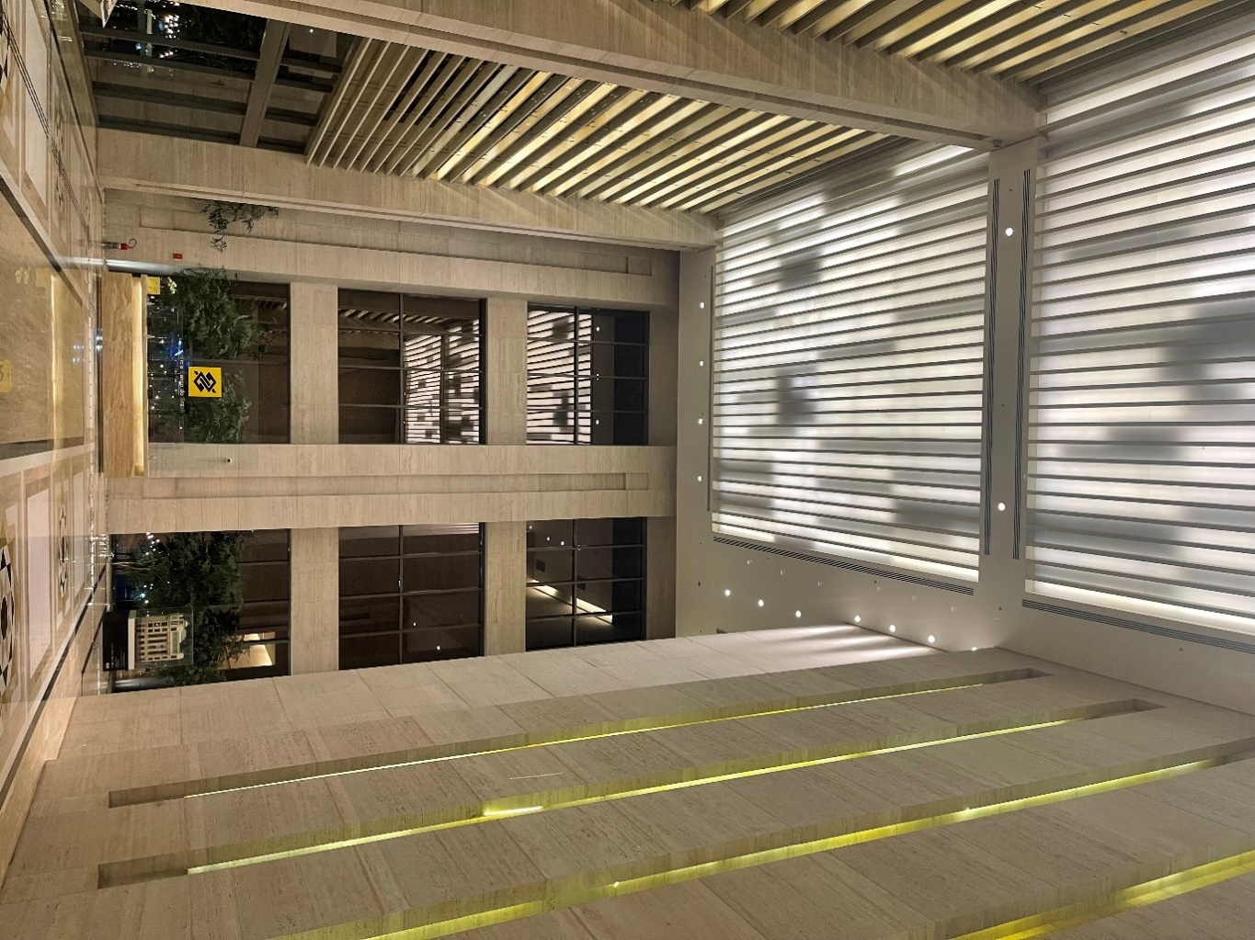
BB's solar plants have already generated around 66 GWh, avoiding the emission of more than 20 thousand tons of CO2 into the atmosphere, equivalent to planting a small forest of two thousand trees. In addition to the environmental gains, we saved R$18.2 million, a saving of 32% compared to the captive market. The objective is to achieve a predicted reduction of R$629 million in 15 years.
Corporate Governance

We adopt the best corporate governance practices, maintaining our commitment to the principles of transparency, accountability, equity and corporate responsibility. Since 2006, we have been listed on B3's Novo Mercado, a segment with the highest standard of corporate governance.
Decisions are made collectively at all levels. Thus, the administration has a structure of committees, subcommittees and strategic commissions that guarantee agility, quality and security in decision-making.
Our governance structure is made up of the General Shareholders’ Meeting; by the Board of Directors (CA) and its advisory committees – Audit Committee (Coaud); People, Remuneration and Eligibility Committee (Corem); Risk and Capital Committee (Coris), Technology and Innovation Committee (Cotei) and Business Sustainability Committee (Cosem); by the Executive Board, composed of the Board of Directors (President and Vice-Presidents) and other Directors; and by the Supervisory Board. The Board of Directors also receives advice from Internal Audit and an Independent Audit.
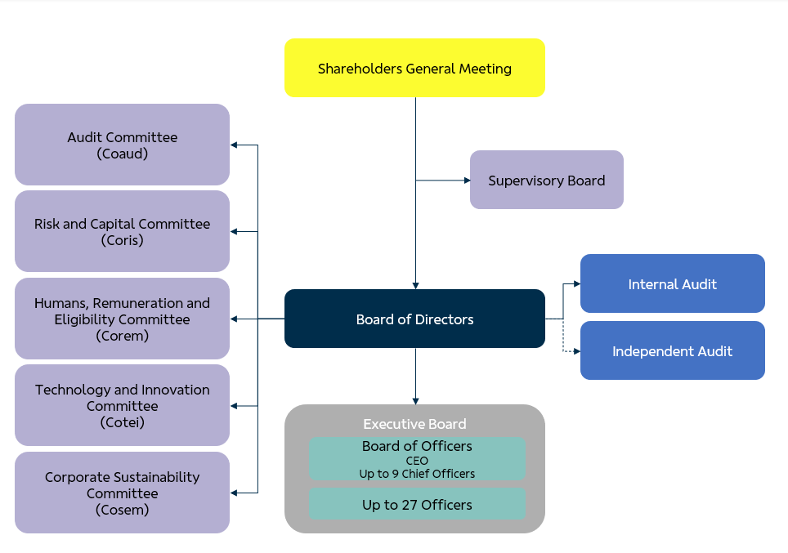
The CA, an independent collegial decision-making body, has strategic, guiding, elective and supervisory responsibilities, as provided for in Law and the Bylaws. At least 30% of the members are independent, as defined in the legislation and in the B3 Novo Mercado Regulations.
In April/2023, we held a General Shareholders' Meeting to elect board members for the 2023/2025 term, at which time those nominated by the controlling shareholder and minority shareholders were elected.

Diversity, Equity, and Inclusion
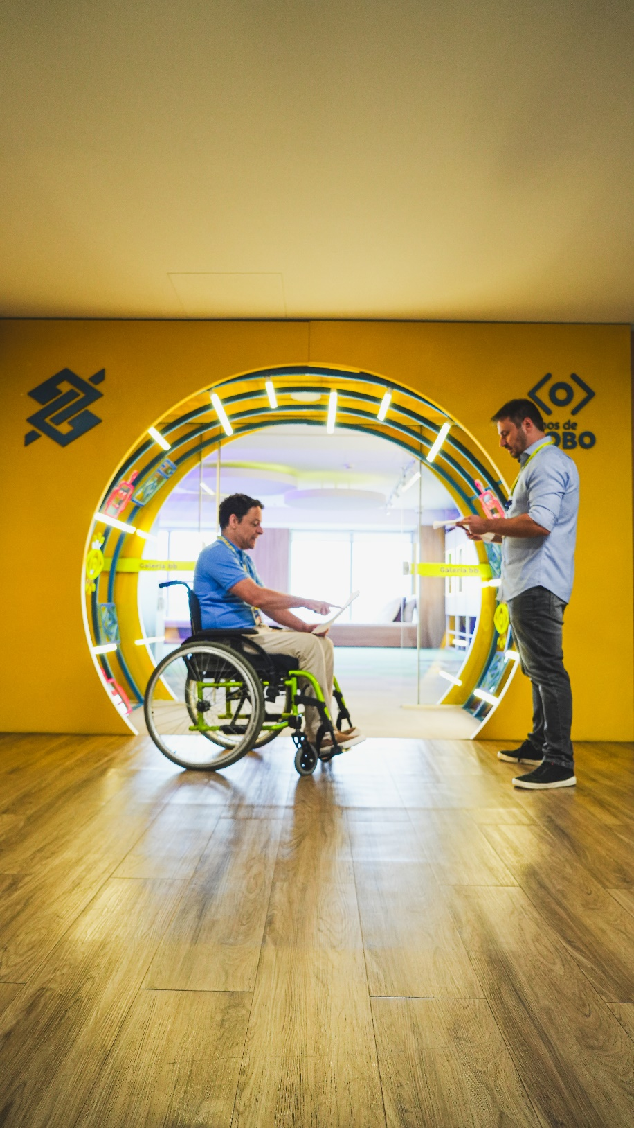
In September, our Board of Officers was invited to speak about the importance of the ESG and Diversity agenda at UN headquarters in New York. There we promoted action in Times Square in favor of the Amazon and indigenous peoples. In November, we participated in the Opening Plenary of the 12th UN Global Business and Human Rights Forum, in Geneva, where we were able to express internationally our commitment to promoting ethnic-racial equity and combating structural racism in the country, mentioning the Open Charter from BB to black movements.
Throughout the second semester, we held six editions of the Diversity, Equity and Inclusion Advisory Council, which was attended by members of BB's executive board and representatives of civil society, market experts and references on the topic. In each of the meetings, we deepen reflections on the challenges, opportunities and best practices for each group of the social markers of difference prioritized in our program: LGBTQIAPN+, Gender, Neurodivergents, Generations, Race and Ethnicity and People with Disabilities.
All the experimentation and acceleration that we promoted on the topic, throughout 2023, also resulted in the proposal and approval of the review and expansion of the Diversity, Equity and Inclusion Program and the launch of BB Ações Diversidade IS, a fund that aims to allocate its resources in shares of companies that adopt the best diversity practices, using the new Brazilian stock exchange index (B3) as a reference.
We have advanced in the diversity of BB's management. Currently, we have 50% women among the eight members of the Board of Directors and 44% women on the Board of Officers.
Another important advance in the quarter was the inclusion of a clause promoting diversity in contracts with suppliers. Our specific supplier relationship policy aims to promote equity, diversity, ethics and integrity in hiring and partnerships with service providers.
In November, we signed a partnership with Fundação Banco do Brasil and Faculdade Zumbi dos Palmares, through which we will invest in research applied to racial issues and that present mechanisms for historical review, acceleration of representation and combating discrimination in Brazil, which notice will be released in 2024.
Also, in November, Black Consciousness Month, we launched the Ourocard Raízes (Roots) card and a notice of socioeconomic projects aimed at black women.

Diversity Recognitions
We were selected to be part of B3's iDiversa, the first Latin American index to combine, in a single indicator, gender and race criteria, and recognizes listed companies that stand out in terms of diversity, in addition to promoting greater representation of these groups in the market.
The index was constructed based on public data available in the Reference Form of companies listed on the stock exchange. BB has a weight of 4.71 in the first portfolio released.
In October, during the CEBDS Sustainable Congress 2023, we received two awards recognizing advances in the diversity of BB's management: Women on the Board, for the 50% of women among the eight members of the Board of Directors and Female Leadership, where the Bank achieved 44% of women on the Board of Officers.
We won an award for gender balance at CA, through an initiative that recognizes publicly traded companies in G20 countries and the Global Private Banking Awards recognized BB Private as the Best Private Bank in Latin America in the Diversity & Inclusion category.


Sport and Culture
We believe that sponsoring sport brings rejuvenation to our brand and associates us with attributes that we consider important: quality of life, sustainability and preservation of the environment.
We are one of the biggest supporters of Brazilian sport, including Olympic sports. Among the sponsored sports are volleyball, surfing, skateboarding and street running. We also support eSports, as well as sponsor individual athletes in different sports.
We recognize that sport teaches, entertains, makes dreams come true, encourages unity and maximizes achievements. The objective of the incentive is to continue to excite, surprise, help to develop sports and, above all, project new idols.
We also believe that culture generates connection. It inspires, raises awareness and creates repertoire. It promotes critical thinking and has the power to impact lives. Therefore, we promote access to national and international cultural productions, through a simple and inclusive approach that provokes identification and representation.
We are present, with the Banco do Brasil Cultural Centers (CCBB), in four major Brazilian capitals – Rio de Janeiro, São Paulo, Brasília and Belo Horizonte. In 2023, we received more than 3.7 million visitors, carrying out projects in the areas of performing arts, music, exhibitions, cinema, ideas and educational program actions. With this, the CCBBs consolidate themselves as one of the main cultural centers in the Brazilian and international scene.
The highlight this year was the launch of the Cultural Sponsorship Notice to make up the CCBBs program for the period 2023-2025. There were more than 6,600 projects registered - with emphasis on the North and Northeast regions, which had record numbers of registrations. 137 projects were selected, from all regions of the country, respecting criteria of diversity, plurality and decentralization of development.

Awards and Recognition

January
We were recognized, for the tenth consecutive time, with the Top Employers certification, an award granted by the independent Dutch research foundation Top Employers Institute. We are the only Brazilian company certified in all editions and have been recognized as an employer that develops talent at all levels of the organization and that strives to implement and continually optimize people management policies and practices.
We were listed in the annual Global 500 ranking, which recognizes the 500 most valuable brands in the world. The assessment is from the British consultancy Brand Finance and the result was released during the Davos Economic Forum, in Switzerland.
We are classified, for the fourth time, as the most sustainable bank on the planet according to the ranking of the 100 Most Sustainable Corporations in the World 2023 – Global 100, by Corporate Knights. In 2023, in addition to its leadership position among banks, BB is the only Brazilian company classified, ranking 15th among companies in general.
BB's Private segment was listed in the Leaders League 2023 Ranking, in the Wealth Management - Private Bank Brasil category, which recognizes the best strategies in Brazil in asset and fortune management for Private clients.
February
We received international recognition in the Platinum and Gold categories of the 2023 AVA Digital Awards, taking place in the United States. Awards from around the world are evaluated by professionals who work in the US communications and marketing industry.
We were recognized at the Lusófonos Creativity Awards, when seven initiatives won 13 trophies, in different categories.
For the 2nd time in a row, we won the award for Most Sustainable Bank in South America, by Capital Finance International – CFI.co.
March
Abrarec – Brazilian Association of Business Client Relations announced the winners of the Ombudsman Brazil Award and we won the best innovation case at Ombudsman Brazil for the 10th time.
We won the bronze trophy at the 17th Steve Awards for our broad, accessible service for deaf and speech-impaired people. The event that took place in the USA recognized service in Libras in the category of Innovation in Customer Service in the Financial Services Industry.
Our Private segment was recognized for the second year in a row as the best Private Bank in Brazil in 2023 by World Business Outlook, a communication vehicle specialized in covering and analyzing finance, international business and the global economy. In this same award, we were also recognized in the categories Best Private Bank for Women, Best Private Bank for Succession Planning and Most Sustainable Private Bank in Brazil.
Private was also awarded, for the second year in a row, as the best Private institution in Brazil at the International Business Magazine 2023 awards, organized by the communication vehicle specialized in the financial market and with international coverage. In this same edition of the awards, we were recognized in the following categories:
• Fast Growing in Private Bank;
• Best Financial Advisory for Women;
• Better Wealth Management;
• Best Financial Advisory for Agribusiness in Brazil.
April
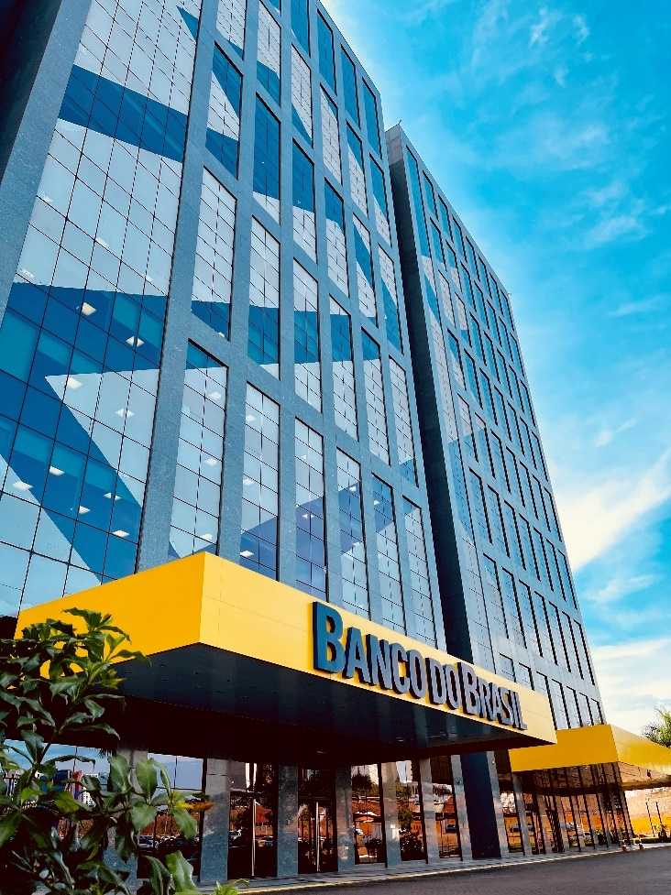
Our president, Tarciana Medeiros, led the Forbes Brasil reputation ranking and is the CEO with the best reputation on LinkedIn according to Forbes Brasil magazine. The ranking scores were calculated using the Digital Maturity Matrix, a methodology that analyzes the presence and strategy of leaders in a qualitative and quantitative way. The Matrix considers more than 30 criteria and parameters in the dimensions of presence, strategy, social capital and executive reputation, delivering a holistic view to the analysis and providing an effective assessment for the strategy of leaders and brands on LinkedIn.
We were recognized in the Private segment as the Best institution in Brazil in Innovation focused on Wealth Management at The Global Economics Awards 2023, organized by the communication vehicle specialized in the financial market and with international coverage.
May
Bacen awarded the institutions that achieved the best performance in the Annual Ranking of projections of the 2022 Focus Bulletin. We won 1st place in the classification for the Selic Rate. BB Asset was recognized for 1st place in the IPCA projection – Medium Term Administered Prices.
We won the fourth championship in one of the categories of the Global CCU Awards, which is an award that recognizes the best corporate universities on a global scale, which create strategic value for people, business, society and the planet. The gold came in the Impact Technologies category, with the Academia de Educadores project.
We won recognition as the best Private Bank in Brazil in the 2023 edition of the World Business Outlook Awards, organized by the communication vehicle specialized in covering and analyzing finance, international business and the global economy.
June
Our president, Tarciana Medeiros, received the Personality of the Year award, offered by the Brazilian Chamber of Commerce in the United Kingdom in recognition of the achievements of companies and their leaders who have contributed to strengthening trade ties between Brazil and the United Kingdom.
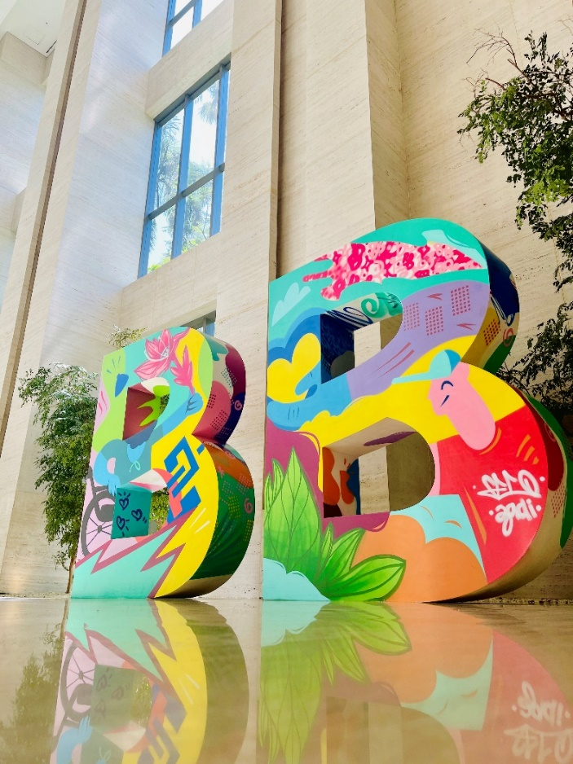
We won the 11th edition of the Global Finance Award – The Innovators 2023, in the category "Top Innovations in Finance 2023 - Marketing" with the case "Metaverse BraBlox", whose proposal is to connect the young audience to the company's brand, so that in the future they can become customers of the Bank.
We won the 2nd edition of the FIDinsiders 2023 Award - Digital Finance for Society in the category "Innovation in the Offer of Financial Solutions for Small and Medium Rural Producers". The FIDInsiders Award aims to recognize and disseminate innovative solutions that contribute to improving the democratization of finance in Brazil.
We also had a better score in the ESG rating by Sustainalytics, reaching the "Low Risk" rating and a score of 19.3 (in 2022 we scored 20.6 - Medium Risk). The assessment reflects BB's performance on issues such as data privacy and security, governance, business ethics, risk management, social and environmental performance, among others.
We won the Latam 2023 Award, offered by the Alianza Latinoamericana de Organizaciones para la Interacción con Clientes (Aloic), the award recognizes the best practices in customer relations on the continent.
We were recognized, with the gold trophy, for the best performance in South America in innovation for customer service in the 21st edition of CMS Financial Innovation.
July
We were nominated again for the ReclameAqui award, in the Banks category, demonstrating our good reputation in the opinion of consumers. To be nominated to participate in the awards, companies must have status: Good, great or be RA 1000 (maximum reputation seal provided by the website). The ReclameAqui Award is in its 13th edition, and this is the 5th consecutive time that BB is nominated for this category.
We were listed for the eighth consecutive year in the FTSE4Good Index Series, an index of the London Stock Exchange that evaluates and ranks companies with the best environmental, social and corporate governance practices. 2. BB obtained an overall score of 4.1 in 2023, compared to 3.6 in 2022, and achieved a maximum score (5.0) in the environmental dimension.
We had another international recognition, this time as the best Brazilian bank in the corporate governance category, conferred by the Global Banking & Finance Review. The British Global Banking & Finance Review is an international online platform that offers news, analysis and opinions on the latest trends and innovations in the banking and finance sector around the world, presenting and discussing topics such as banking, insurance, investments and wealth management, as well as discussing fintechs, banking technology, regulatory issues and corporate social responsibility (ESG).
August
We were recognized by the Brazilian Institute of Public Governance (IBGP) with the Innovation in the Public Sector award with a focus on citizens. The SisconDJ-WEB solution was included in the State Companies Category as the Interconnection solution with the Courts of Justice and Regional Labor Courts.
We were awarded as the Best Private Bank in the Country by the Global Business Awards 2023, organized by Corporate Vision, a vehicle specialized in the international financial market, BB Private was recognized as the Best Private Bank in the Country.
October
We achieved the Abracam Seal of Conformity, designed by the Brazilian Foreign Exchange Association, which evaluates the policy, procedures and internal controls adopted by institutions with a view to preventing the use of the financial system to commit crimes related to foreign exchange operations.
November
We were recognized in the Best Performance awards, which is now in its 8th national edition. The initiative brought together the main banks, insurance companies, service providers, fintechs and startups in the financial ecosystem. Focusing on innovation and customer experience, the objective is to recognize and disseminate the best practices in the market. We won in four categories: Excellence in ESG; Best Post-Purchase Support; Excellence in customer attraction, loyalty and retention; and Excellence in Digital Customer/Consumer Service (UX, CX and Customer Success).
We were awarded in the "Bank of the Year 2023" as the best bank in Brazil in 2023. The award ceremony took place in London, England. The event is organized by the Financial Times newspaper and is considered the Oscars of the financial industry. For the award, information related to the growth and performance of companies is considered, as well as success stories regarding strategic initiatives, technology and products and services. We won seven trophies in the Best Performance award and one in the Innovative award.
December
We were certified as a Top Employer, for the 11th consecutive year. This certification recognizes companies with the best HR practices, promoted by the Top Employers Institute, in the Netherlands.

People management

The job market evolves, following needs, trends and new technologies and BB is a protagonist in this evolution. We live in an era in which transformations happen more quickly and responses must follow the same pace.
This transformation also occurs through digital acceleration, which positively influences the way we work, using agile methods on a daily basis and seeking to reskill and upskill our teams.
Focused on the premise of continually improving the customer experience, we called on 61% of those approved in the competition, that is, four thousand new employees, thereby energizing our staff with the arrival of new professionals, including those directly working in the areas of technology and cybersecurity.
We made progress in the onboarding process for employees from the last competition, adding the variables diversity and inclusion. To this end, we prepare corporate educators with training aimed at understanding and meeting these variables.
Upon arrival and after the first 15 days at the company, the employee participates in the game “Tô on no BB”, which covers several essential topics such as Corporate Strategy, Financial Ecosystem, BB Results, Communication and Diversity, as a way of consolidating the knowledge obtained about the company.
Paying close attention to employee satisfaction and engagement, which contributes to greater productivity and efficiency, is part of our Corporate Strategy and is our constant focus.
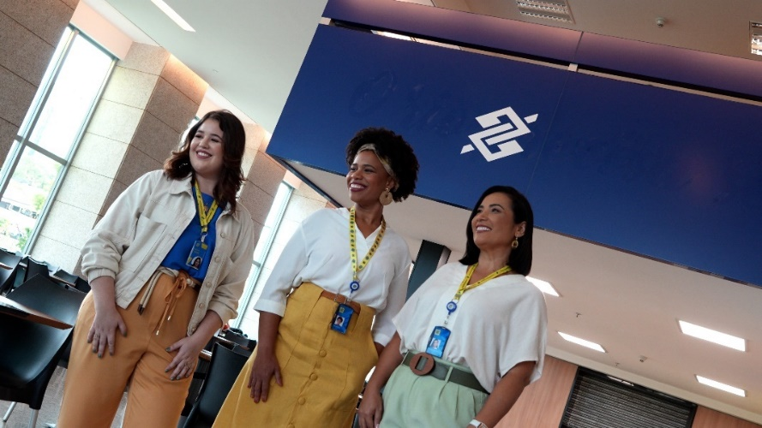

We launched the Race is Priority Program, with the aim of selecting and developing career acceleration for employees of underrepresented races, starting with black people (black and brown) at BB. The Pilot Program will identify black people with the potential to act as leaders. The actions also aim to better adapt and highlight the S of ASG in the company.
We carried out another edition of the Great Place to Work survey. This year, 50 thousand employees were invited to respond, who were able to contribute to the development of people management at Banco do Brasil and highlight the enterprise strengths to the market. After all, the best people make the best companies. A great company to work gives each employee the opportunity to be who they are, offers opportunities to build careers, with benefits and incentives that they value, guided by ethics and with a sense of purpose.
We held a webinar in reference to Yellow September, providing tools to help those who need emotional support. We expanded remote work, reaching more than 16 thousand employees in order to provide a better quality of life for employees, aligned with the objectives of the Corporate Strategy - ECBB by contributing to digital transformation and innovation, in addition to enabling the reduction of expenses with rental of physical spaces.
We started a project that aims to make the BB employee's journey unique, have enchanting moments and generate positive impacts, initially affecting people indicators and, later, business indicators. This project will lead us to the establishment of Employee Experience governance, which is as important as the governance of the Customer Journey.
In December, based on research, information, interviews and visits to BB units, the concept of BB Employee Experience was created. This initiative is connected and aligned with the BB Employee Value Proposition, Organizational Culture and ECBB 2024-2028.
We also highlight our Saúde no Prato Program, which aims to improve employees' eating habits, positively reflecting on their well-being and quality of life through online consultations with the Einstein Nutritional Teleorientation service.
The BB Volunteer Program completed 22 years and, among the celebration actions, an event was held to recognize volunteers, for all the social transformation generated in the communities where they work. Tributes, sharing of experiences and results achieved were some of the highlights of the meeting.
Recognizing and valuing employees is a continuous and fundamental action. Therefore, the edition of the leadership talent identification program, PIT+, which mapped more than 11 thousand employees using AI and data crossing. This has converted the development of leadership skills into day-to-day results for the client. and to the Bank.
We also highlight the holding of the 4th CEI season, BB's annual event on Compliance, Ethics and Integrity. The central theme for 2023 is “Building Sustainable Relationships”. The event took place in December and aimed to discuss emerging themes aligned with the Bank's strategic objectives. Topics such as social, environmental and climate responsibility, ethics in the use of artificial intelligence, cyber business, diversity, 10 years of the anti-corruption law, harassment and workplace violence, conduct risk, customer and user relationship policy and operational losses were part of the program.

Internal Controls and Risk Management
In 2023, our Internal Control Effectiveness index monitored the effectiveness and quality of controls in 5,504 Bank units.
On the ESG topic, we evaluated funding products with a focus on greenwashing, applied tests to more than 480 thousand operations in the Sustainable Credit Portfolio and improved the validation methodology with the inclusion of tests that assess the existence of discriminatory biases in people analytics models.
Within the scope of risk and control management, we have evolved in the development of automated tools for monitoring the internal control system and the main risks associated with the Institution's activities. Among these, CRIVO (Compliance, Risk and Intelligence in Operations Verification) stands out, a real-time monitoring platform for the compliance of products and services sold by the Bank, using innovative digital compliance technologies, analytics and artificial intelligence. This platform enables a more comprehensive and efficient assessment of operations, allowing the identification of irregularities and the activation of induction for correction.
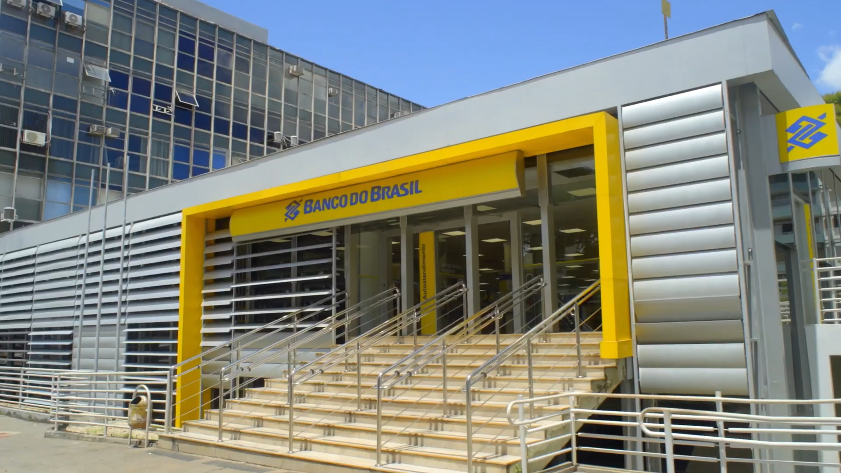
Through the Simplifique Platform, employees suggest improvements in controls, processes, products and services. In 2023, we implemented more than 200 suggestions, reducing more than 1.7 million hours in the customer service journey and the use of 13 million sheets of paper.
The Compliance Program was improved with the inclusion of the guide “Diversity, Equity and Inclusion – DE&I” and the approach to ethics in AI. We also held the 4th Season of Compliance, Ethics and Integrity, disseminating best practices and impacting more than 3,500 employees.
In the Customer and User Relationship Policy, we carry out actions focused on serving vulnerable customers and internal acculturation, addressing topics such as ESG, DE&I, Suitability, Financial Education and Ethics.
We reviewed the Model Risk Management Framework in order to align it with best market practices and coverage of exposures related to Artificial Intelligence models. We implement the Continuous Monitoring Plan in liquidity risk models.
In 2023, processes were also developed for the active monitoring of risk indicators and, with active participation in the 2024 Integrated Planning.
Social, Environmental and Climate Risks and Opportunities
In June we published the first Social, Environmental and Climate Risks and Opportunities (GRSAC) report, available on our Investor Relations website.
The GRSAC report is aligned with the recommendations of the Task Force on Climate-related Financial Disclosures (TCFD), a global initiative that aims to improve transparency in the disclosure of climate-related financial information, to which the Bank joined in May 2021. It is an important milestone in the sustainability agenda for the financial sector, as it increases the quality of financial information related to social, environmental and climate issues, and reinforces the agenda of ESG commitments and goals. In 2024, we will continue investing in initiatives to mitigate social, environmental and climate risks, in line with the commitments made in the sustainability agenda.

Independent Audit
The hiring of services unrelated to external auditing, and to avoid conflicts of interest, loss of independence or objectivity of independent auditors, we adopt procedures based on applicable legislation and standards and the best internationally accepted principles related to the topic. These principles are as follows: (i) the auditor should not audit his own work, (ii) the auditor should not perform managerial functions for his client and (iii) the auditor should not promote the client's interests. At Banco do Brasil, the hiring of services related to external auditing must be preceded by an opinion from the Audit Committee.
We inform you that Deloitte Touche Tohmatsu Auditores Independentes Ltda. did not provide services that could affect its independence, ratified through the adherence of its professionals to the relevant ethical and independence standards, in a way that meets or exceeds the standards established by the International Federation of Accountants (IFAC), the Federal Accounting Council (CFC ), Securities and Exchange Commission (CVM), Central Bank of Brazil (Bacen), Private Insurance Superintendency (Susep), National Supplementary Pension Superintendence (Previc) and other regulatory agencies. These policies and procedures covering areas such as personal independence, post-employment relationships, professional rotation, as well as the approval of audit services and other services, are subject to constant monitoring.

Securities and Information of Affiliates and Subsidiaries
In accordance with art. 8th of Circular Bacen 3,068/2001, we affirm our intention and financial capacity to maintain, until maturity, the securities classified in the “Securities Held to Maturity” category. Our financial capacity is supported by cash flow projections that do not consider the possibility of selling these securities. The breakdown of securities by category and the reclassification of securities can be found in explanatory note 10 – Securities. The amounts referring to unrealized gains and losses in the period, relating to securities, are disclosed in explanatory note 30 – Risk and Capital Management.
In compliance with article 243 of Law 6,404/1976, we inform that the company's investments in associated and controlled companies are listed in explanatory notes 2 – Presentation of Financial Statements and 14 – Investments.
In compliance with article 243 of Law 6,404/1976, we inform that the company's investments in associated and controlled companies are listed in explanatory notes 2 – Presentation of Financial Statements and 14 – Investments.
Additional Clarifications
We have R$1.0 billion (individual and consolidated) in unactivated tax credits, presented in explanatory note 22 - Taxes in the Individual and Consolidated Financial Statements (subitem “f”). We kept recorded in compensation accounts, in accordance with the rules set out in the Financial Institutions Accounting Plan (Cosif), the amount of R$19.2 billion arising from co-obligations and risks in guarantees provided to customers and companies belonging to the Banco do Brasil Conglomerate.
We annually publish the investments made as a result of the exercise of public policies in our Annual Letter on Public Policies and Corporate Governance, available on our website (ri.bb.com.br).
Banco do Brasil, its shareholders, administrators and members of the Fiscal Council undertake to resolve any and all disputes or controversies related to the Novo Mercado Listing Regulations through the B3 Market Arbitration Chamber, in accordance with the arbitration clause contained in the Bylaws Banco do Brasil Social.
This Management Report was prepared based on the Individual and Consolidated Financial Statements prepared in the Accounting Standard of Institutions Regulated by the Central Bank of Brazil (Cosif). For more information, the Reference Form, the Performance Analysis report and the Institutional Presentation are available on the Investor Relations website (ir.bb.com.br).

