

Management
Report

September 30, 2024

Management Report | 9M24

Dear reader,
In the first nine months of 2024, we recorded net profit of R$26.7 billion, an increase of 6.9% compared to the same period in 2023, supported by the successful execution of our strategic planning. We have continually worked to deliver a Banco do Brasil for each of our customers, with close relationships and phygital experience. In this way, business generation is done in a sustainable way and the return to our shareholders and society is an organic consequence of our way of being BB.
In addition to a result that remunerates shareholders and supports credit growth, with R$63.4 billion in value added to society, when we consider taxes, salaries, dividends and other components. The classified portfolio exceeded R$1.0 trillion, with important developments in all the segments in which we operate.
In the Individuals portfolio, emphasis on payroll loans, which reached R$137.2 billion. In the companies segment, both MSMEs and large companies and the government segment showed growth, demonstrating our commitment to these segments.
In agribusiness, we highlight the positive performance of the expanded portfolio (13.7%), compared to the same period of the previous year. In the 2024/2025 Harvest Plan, we disbursed R$63.4 billion. Furthermore, there was a disbursement of R$11.0 billion in the agricultural value chain, totaling R$74.4 billion. There were

more than 200 thousand operations contracted in the period in more than 4.8 thousand municipalities across the country, 69.8% of which were destined for family farming (Pronaf) and medium producers (Pronamp).
In September, we were protagonists in leading the sustainable economy agenda and presenting BB's strength in the ESG agenda at the UN Global Compact and Climate Week events, both in New York/USA. We highlight BB as the main hub for attracting external resources for green initiatives in the country, as well as being pioneers in bioeconomy and carbon credit solutions, with these topics already advancing in our portfolio.
Furthermore, on the same occasion, we promoted the first edition of Investor Day in the USA, an event that brought together relevant institutional investors, market analysts and other financial market professionals.
In 3Q24, we continued to stand out for the reduction in complaints received in the Central Bank Complaints Ranking. We maintained 14th place among 15 financial and payment institutions, continuing with our best result for the 9th consecutive quarter.
We invite you to learn more about our deliveries on the following pages.

Good reading!

Consolidated Financial Statements Results
We achieved net profit of R$26.7 billion in 9M24, reflecting the good performance in credit, funding, services, conglomerate businesses and focus on cost control. Our classified credit portfolio exceeded R$1.0 trillion, growth of 11.1% compared to September/23. The portfolio for individuals grew 7.5%. The Corporate portfolio, without agricultural companies, grew 10.4%, with emphasis on the balance with Large Business clients, which increased to R$132.3 billion. Credit operations in agribusiness, with small, medium and large rural producers and with companies operating in the segment, grew by 12.2% in the same period. The Basel Index reached 14.66% and the Core Capital Index ended September at 11.77%.
To find out more details about the profit and loss items for the period, see the Explanatory Notes contained in the Financial Statements and the Performance Analysis Report.
Net profit
of R$26.7 billion
growth of 6.9%
in relation to September/23
Classified Credit Portfolio
R$ 1.0 trillion
growth of 11.1%
in relation to September/23

Banco do Brasil |  |  | BB Consolidated
Earnings (R$ million) | 9M24 | 9M23 | 9M24 | 9M23
Net Income | 26,572 | 24,835 | 26,667 | 24,957
Income from Financial Intermediation | 40,873 | 40,084 | 49,360 | 47,933
Provision for losses associated with credit risk | (31,556) | (21,928) | (31,692) | (22,079)
Fee Income | 15,842 | 15,761 | 26,285 | 25,088
Administrative and Personnel Expenses | (27,685) | (26,223) | (28,922) | (27,606)
Equity (R$ million) | Sep/24 | Dec/23 | Sep/24 | Dec/23
Assets | 2,436,861 | 2,208,054 | 2,469,586 | 2,172,480
Classified Loan Portfolio | 1,033,901 | 964,925 | 1,050,006 | 975,349
Resources from Customers | 819,522 | 787,539 | 851,556 | 811,944
Shareholders Equity | 177,681 | 163,638 | 187,419 | 173,076

Shareholders
We have a base of 1.4 million shareholders, 98.9% of which are individuals. At the end of September, our shareholding composition was distributed between 50% of shares held by the Federal Union, 49.6% in free float and 0.4% in treasury. Local investors held 76% of the shares, and foreigners 24%. Our shares (BBAS3) represented 3.5% of the Ibovespa in the last four months. In the last 12 months (September/23 to September/24), our shares appreciated by 26.2%.
The Extraordinary General Meeting, held on 02/02/2024, approved the split of 100% of BB's shares (BBAS3), thus attributing 01 (one) new share for each share issued. The base date for the split to be effective was April 15, 2024.

Shareholder Remuneration
For the 2024 financial year, Banco do Brasil's Board of Directors approved the proposal to increase the distribution of its profit, from 40% to 45%, in the form of dividends and/or Interest on Own Capital (IOC). The decision was taken based on the guidelines contained in the Specific Shareholder Remuneration Policy, in particular, the Bank's future results, its financial condition and cash needs, the Risk Apetite Statement, its capital goals and projections, perspectives of current and potential markets, existing investment opportunities and operational capacity. The total allocated to shareholders in 9M24 was R$11.4 billion and the value per share was R$2.208.

Corporate Strategy

Our Corporate Strategy (ECBB) has a five-year time horizon and is reviewed every year.
ECBB 2024-2028 has the following strategic objectives: (a) provide the best experience to customers at all times; (b) create value and generate sustainable results; (c) be a protagonist in sustainability and in the promotion of business and ESG practices; (d) evolve our way of working to accelerate digital transformation and innovation; and (e) have people engaged with BB's values and promoting collaboration, respect and inclusion.
Our purpose is “To be close and relevant in people’s lives at all times”.
Aligned with our purpose and reinforcing the Company's organizational identity, we improved our values to make the principles that guide our

actions and inspire our team's deliveries even clearer, with an emphasis on diversity. Thus, our values are: Proximity, Innovation, Integrity, Efficiency, Commitment to Society and Diversity.
As a result of ECBB, in February 2024, initiatives distributed across nine major fronts, called Strategic Movements, were prioritized, which, in addition to accelerating the achievement of objectives, differentiate BB in relation to the market to achieve long-term success.
These movements address major challenges that surround the National Financial System related to topics such as digital assets, bank as a service, operations in value chains, hyperpersonalization, payment methods, ESG businesses, among others.

Clients

The customer is at the center of our strategy and we are focused on the hyper-personalization of our relationships with the aim of delivering a bank for each customer and considering the 360° vision of each one of them.
We have been working with agile marketing and CRM has been a great ally. In 9M24, 2,800 personalized strategies were carried out, which generated approximately 475 million customer contacts. More than 8,800 clusters of individuals and legal entities were identified, based on analytical intelligence, using predictive, behavioral and business propensity models.
Furthermore, during the 9M24, 69.8% of the total volume disbursed in credit to individuals was made by customers approached in commercial strategies in targeted channels. In total, there were 63.5 million interactions in the period to offer credit, and 10.3 million deals were completed, including digital and physical channels.
For micro and small companies, we have expanded the services of our conciliation tool within the PJ Panel. Currently, we offer all payment and receipt information in one place, both from BB and other institutions, including sales via Cards and Pix, which allows transactions to be reconciled using any machine on the market. All this with the assistance of ARI (Intelligent Recommendations Area), which brings insights that support the day-to-day management of MSEs and reached 47 thousand unique users with 300 thousand messages and 38 types of recommendations.
It is worth highlighting our work with female entrepreneurship. We have specific credit lines such as FCO Mulheres Empreendedoras, Giro Mulher
Empreendedora and Working Capital Extension – Mãe Empreendedora. There are 1.3 million companies run by women, representing 42% of total customers and 37% of the balance of the MSE credit portfolio.
The business relationship with Corporate and Large Corporate companies is carried out in a specialized manner. Currently, there are more than 1,400 business groups supported by highly qualified teams, with national and international coverage, in corporate banking offices, platforms and middle office structures.
Furthermore, we continue to evolve on the Liga PJ platform (ligapj.com.br), a place where any entrepreneur, whether a BB account holder or not, can access content ranging from information to start a business to a more mature moment for the company, expanding its sales. We reached 27 thousand unique customers with more than two million visits.
To strengthen the financial education of children and adolescents, in August 2024, we launched “Meu Cash”, a solution developed for the BB Cash account that allows customers to know their expenses in different categories to plan financially. There are already 1.1 million customers between 0 and 17 years old, with around 30% of all children and teenagers using BB Cash. These customers show engagement above 95%, with card usage above 70% and transactions via Pix above 67%. Furthermore, 30% of these customers have some type of financial investment, with an average ticket of R$4,400.

Technology and Inovation

Our ability to innovate over the years is one of the factors that has contributed to the construction of our history and the sustainable results we have achieved.
Our technology is structured on enabling platforms, including Analytics, Mobile, Artificial Intelligence, LowCode and Cloud, through which we build Banco do Brasil's products and services. This management model allows us to accelerate and scale new technologies, standardize and provide greater quality to deliveries, positively impacting our ability to respond more quickly to market changes and the needs of our customers.


This strategy is complementary to the continuous escalation of a more integrated work model between all areas of BB, which continues to expand, supported by our cultural transformation. We have solutions that impact the customer experience and enable business and results. We carried out more than 3 trillion IT transactions in 2024. Over 300 deployments per day and in terms of automated tests, there were more than 520 thousand, with the purpose of guaranteeing the quality of the technological solutions provided, customer satisfaction and recognition.
Artificial Intelligence and Analytics
We enable new businesses and innovations through the Companies Value Chain solution, we bring together suppliers and buyers to conduct good
and profitable business for all parties. The tool provides relevant elements to support business, such as: links between companies; unique suppliers and buyers; amounts moved by companies; resulting in a database with 3.6 billion records. Since the implementation of the solution, in July/2024, BB has directly benefited more than seven thousand anchor companies, including suppliers and buyers.
PIX
We integrate new business opportunities with cutting-edge technology to improve the customer experience. In this third quarter, for example, we carried out a pilot of solutions that expand your business opportunities through BaaS and Pix with innovative solutions, such as: Pix by approximation, Pix on credit cards, Pix on BB Pay.
Digital Channels
The use of our digital channels accounts for 93.7% of customer transactions, reflecting the global trend towards banking digitization.
We reached a record 24.2 million users on the BB App in the individual segment. Digital platforms account for 38.6% of personal credit and 27% of service operations, such as investments, account openings and insurance.
The BB Super App is one of the best rated on the market, positioned among the 10 most popular apps on the home screen of Brazilians' cell phones. In a process of continuous improvement, this quarter, BB implemented an exclusive journey for young people on the BB App, with a modern interface integrated with WhatsApp that, in the pilot phase alone, had more than two million accesses specifically from this audience.
BB WhatsApp reached 18 million total users, with 98.4% resolution of service requests via bot, without overflow to human service.

BB Pay integrates payment methods and functionalities in a single solution, contributing convenience and business opportunities for legal entities. In 3Q24, the solution transacted over R$2.3 billion, completing more than 3 million payment transactions, a 15% increase compared to 2Q24. The accumulated volume for the year already exceeds R$5.8 billion.
Open Finance
We increased the number of customers with active consent in Open Finance, reaching 2.1 million, of which 1.3 million are already consents without expiration date, which contributes to the sustainability of the benefits obtained from the use of data and improves the customer experience with Open Finance.
Our main use cases have evolved in scope and results. Credit portability using shared data reached the mark of R$1.7 billion in contracted volume for more than 49 thousand customers this quarter, with a historical record of disbursements in this modality in August.
DREX
In line with Banco do Brasil's pioneering role in financial market innovations, in 3Q24 BB, in a consortium with other institutions, was selected by the Central Bank to participate in two initiatives in the second phase of the DREX Pilot: i) tokenized CDB given as collateral for credit operations and ii) Real estate transactions. The pilot foresees the delivery of a functional prototype with an embedded privacy solution and publication of the developed code by June/25.
Digital Security
We invest in qualified professionals, automated solutions and artificial intelligence to protect data, processes and intellectual property, offering a secure digital environment.
In 3Q24, respecting the right to easy access to information about the processing of customers' personal data, BB responded to more than 1 million requests from data subjects, an increase of approximately 3% compared to the services provided in the previous quarter. Of this total, more than 99% were registered through the BB App.

ESG ( Environmental, Social and Governance) Agenda

We are a reference in adopting the best Environmental, Social and Governance practices, establishing actions to identify and manage risks and opportunities. Our ESG commitments are carried out in the Sustainability Plan - Agenda 30 BB, which since 2005 has been our main instrument for promoting social, environmental and climate practices, aligned with the Sustainable Development Goals (SDGs) of the United Nations (UN) and the Paris Agreement. The Plan was revised in August 2023 and includes 47 actions and 100 indicators for the period 2023-2025.
The development of business solutions with social, environmental and climate aspects is guided and declared in our Social, Environmental and Climate Responsibility Policy (PRSAC). It is also supported by BB's Sustainability Guidelines for Credit, updated in June of this year, expanding the restrictive list and exclusion of activities in which we do not assume credit risk.
With a national focus on developing financial solutions and business models that promote the transition to a sustainable and inclusive economy,
BB considers climate change in its planning and invests in business opportunities for a low-carbon economy. Compliance with sustainability indicators and goals is reflected in the remuneration of the entire staff, including senior management, which ensures alignment between business, people and social, environmental and climate issues.
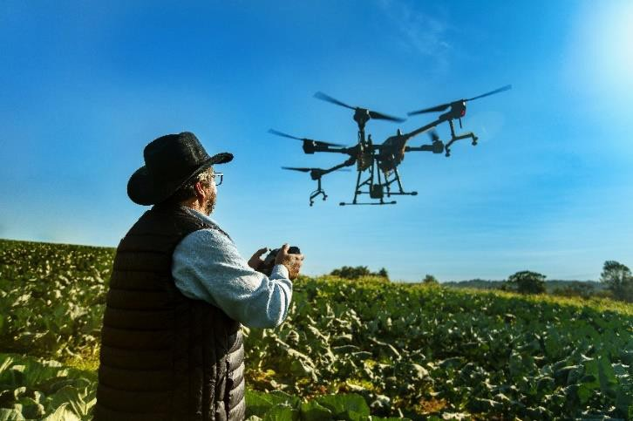
The BB 2030 Commitments for a + Sustainable World bring objectives on four fronts, including sustainable credit and responsible investment and covering our activities in ESG and climate management and seeking to generate positive impacts in the value chain.

BB´s 2030 Commitments for a more Sustainable World
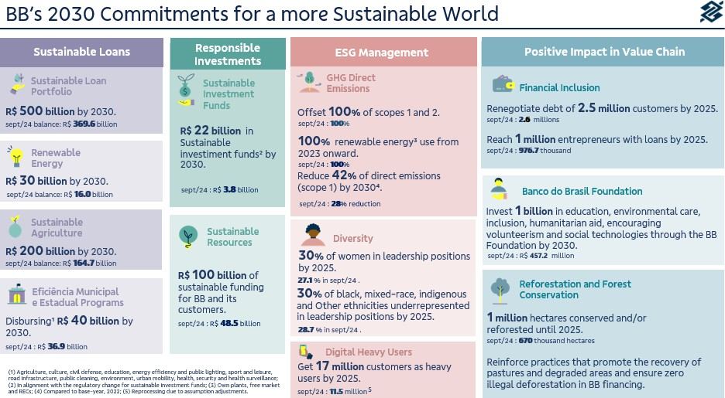

Sustainable Business
In line with our long-term commitments and aiming to help customers transition to a more sustainable economy, at the end of June 2024, we reached R$369.6 billion in sustainable credit operations, a growth of 9.1% in 12 months, with
155.0 billion allocated to agriculture.
This amount was contracted in credit lines with a strong environmental and/or social focus or to finance activities and/or segments that bring positive socio-environmental impacts to the sectors of renewable energy, energy efficiency, construction, sustainable transport and tourism, water, fishing, forestry, sustainable agriculture,

waste management, education, health and local and regional development, in order to reinforce the transformative role in the country's development and in building an increasingly sustainable future for society.
The Sustainable Credit Portfolio is subjected to an independent assessment, which considers the main national and international ESG taxonomies in classifying customers and credit lines that make up the portfolio. The methodology is continually reviewed to incorporate best practices and pioneering references from recent years and add new products with ESG attribute

Sustainable Fundraising
We have intensified our agendas in the interbank market, with multilateral institutions and commercial banks, in addition to our agenda with investors in the international capital market. The result is that in the last 36 months alone, more than R$36 billion in ESG funding has been contracted or negotiated.

The growth in total disbursements in operations with resources raised from multilateral institutions, for example, was 61%. These businesses contribute to diversifying the Bank's funding mix and, consequently, generating credit for Brazilians in all regions of the country, with an emphasis on ESG operations. Between 2023 and 2024, we disbursed approximately R$10.6 billion with multilateral institutions and have negotiated another approximately R$12 billion for disbursement by 2025.

Carbon Market

We reinforce our performance in the voluntary carbon market by supporting clients in the development of projects that generate carbon credits with relevant environmental additionally, offering advice on carrying out GHG emissions inventories and decarbonization plans and offering carbon credits from high-integrity projects to compensate for unmitigated emissions.
In addition to selling carbon credits to be used to offset customer emissions, we offer intermediation opportunities between those who need and those who have carbon credits. Furthermore, we have specific lines to promote projects that contribute to decarbonization, such as renewable energy and energy efficiency.
In 9M24, we achieved over 684 thousand hectares preserved in carbon projects, using the avoided deforestation methodology - REDD+. These are

Bioeconomy and Value Chain
We have been promoting the Bioeconomy, thus we ensure a healthier and more balanced future for future generations. Our work has focused on promoting the Bioeconomy of the Legal Amazon, since the conservation of biodiversity and carbon stocks in the Brazilian Amazon is essential for global climate regulation, in addition to being essential for the local economy, ensuring social and economic benefits for the region.
We contribute to the development of biodiversity in the country, providing financial resources, specialized services, credit lines with attractive conditions and financial consulting services to assist family farmers, associations and cooperatives that work with the Bioeconomy. The objective of
projects that combine environmental preservation and income generation for landowners, in addition to social projects aimed at riverside, traditional and indigenous communities located within and around these projects.
Aiming to diversify the sources of carbon credit generation, in March of this year we launched the Biogas Program, which supports the development of projects based on the generation of biogas and biomethane in agriculture. Since the beginning of the program, we have contracted four projects for the development of carbon credits using this methodology.
In line with diversification, we prospected and signed the first soil carbon contract (ALM) for the recovery of degraded pasture, an area of 1,150 hectares.

our work is to promote the strengthening and productive inclusion of Bioeconomy projects that respect good environmental practices and local cultures.
We are currently one of the main financiers of forest products and biodiversity, with R$1.4 billion in bioeconomy projects in the Legal Amazon, representing a growth of 30% in six months.
Our work in sociobiodiversity is based on five main axes: Forest Restoration and Agroforestry Systems, Low Carbon Agriculture, Connectivity, Forest Bioeconomy and Renewable Energy, in which we support the entire value chain, from the production to the export of bioeconomy products.

Energy Eco- Efficiency
Considering the “BB 2030 for a more sustainable world” commitment, we are investing in decarbonization and ensuring that 100% of the electricity consumed by BB comes from renewable sources. We migrated 441 administrative buildings to the Free Contracting Environment (ACL), ensuring the consumption of clean energy and achieving accumulated savings of R$99.5 million. In 2024, we inaugurated another plant in the state of São Paulo, reaching 16 plants in operation and we have 11 plants under construction, totaling 27 by the end of 2025.
BB's solar plants have already generated around 87.8 GWh, preventing the emission of more than 32.6 thousand tons of CO2 into the atmosphere, equivalent to planting a forest of two hundred and thirty thousand trees.
We launched a new sustainable financial asset, an unprecedented business model in the market. It involves the sale of properties not in use by BB with the possibility of payment in carbon credits. We sold 58 rural and urban properties using this new payment method.
In 2024, we revised the packaging process for cards sent via courier to promote more sustainable practices, resulting in a reduction of approximately five tons of plastic waste per year.

Corporate Governance

We adopt the best corporate governance practices, maintaining our commitment to the principles of transparency, accountability, equity and corporate responsibility. Since 2006, we have been listed on B3's Novo Mercado, a segment with the highest standard of corporate governance.
Decisions are made collectively at all levels. Thus, the administration has a structure of committees, subcommittees and strategic commissions that guarantee agility, quality and security in decision- making.
Our governance structure is made up of the General Shareholders’ Meeting; by the Board of Directors (CA) and its advisory committees – Audit Committee (Coaud); People, Remuneration and Eligibility Committee (Corem); Risk and Capital Committee (Coris), Technology and Innovation Committee (Cotei) and Business Sustainability Committee (Cosem); by the Executive Board, composed of the Board of Directors (President and Vice-Presidents) and other Directors; and by the Supervisory Board. The Board of Directors also
receives advice from Internal Audit and an Independent Audit.
The CA, an independent collegial decision-making body, has, as provided for in Law and the Bylaws, strategic, guiding, elective and supervisory responsibilities. At least 30% of the members are independent, as defined in the legislation and in the B3 Novo Mercado Regulations.
We highlight that, in February 2024, the CA approved the review of the Director Appointment and Succession Policy, including ESG criteria for the composition of the Executive Board (Direx). Nominations of at least half of Direx members must respect the following criteria: minimum of 30% women, according to the gender declared at the time of nomination; and 20% for self-declared “black”, “brown” or “indigenous”, LGBTQIAPN+ and PwD. All the aforementioned percentages must be completed when electing for Direx by with implementation by the end of 2027.
The use of ESG criteria in the appointment of Senior Management raises the Bank's level on the world

stage, aligned with the most inspiring corporate governance practices, capable of driving lasting
and considerable changes in our organizational culture.

Diversity, Equity, and Inclusion
We remain committed to Diversity and are proud to say that we have increased the number of women in leadership positions.
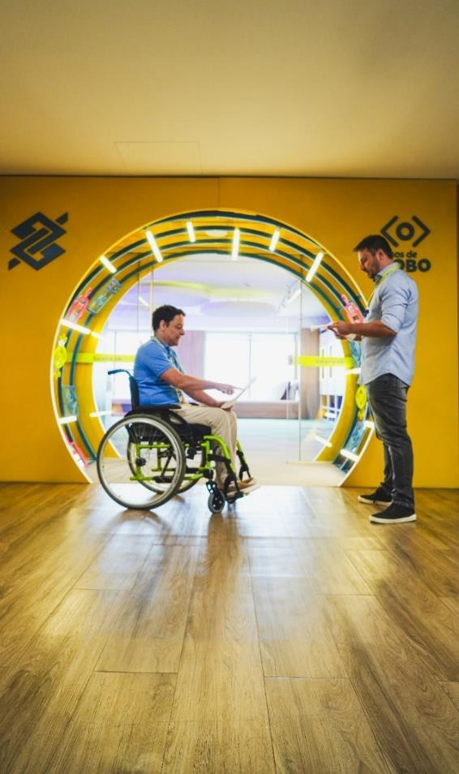
Currently, 44% of our Executive Board (CD) and 50% of our Board of Directors (CA) are women. In addition, two members of the Board of Directors and two of the CA identify as black. Two members of the CD and two of the CA identify as members of the LGBTQIAPN+
community.
We have one of the most diverse boards in the market, recently endorsed by B3, through iDiversa, an index that recognizes companies that stand out for their diversity and representation of these groups.
We are committed to promoting a collaborative, inclusive and equitable work environment. We are also increasingly investing in actions that promote an increase in the number of women in leadership positions.
In August, the BB Foundation and the Palmares Cultural Foundation signed a Memorandum of Understanding support the black Brazilian population in areas such as culture, education, work, income and cultural heritage. The partnership aims to structure initiatives for anti-racist education, racial literacy and preservation of Afro-Brazilian heritage, integrating quilombola communities and traditional peoples.
In September, together with other federal state- owned companies, we officially joined the Pact for Diversity, Equity and Inclusion (Pacto DEI), coordinated by the Ministry of Management and
Innovation in Public Services (MGI), through the Secretariat of Governance of State-Owned Companies. The agreement aims to improve public policies and implement affirmative actions that promote plurality in public companies.

Awards and Recognition

January
We have been certified as a Top Employer for the 11th consecutive year. This certification recognizes companies with the best HR practices and is promoted by the Top Employers Institute.
President Tarciana Medeiros appears in second place in the CEOs Change Makers Brazil ranking, evaluated by Artificial Intelligence on the 100 Brazilian CEOs who have a major impact in the country.
Our brand was considered the strongest in the country. The company Brand Finance named the 500 strongest and most valuable brands in the world at the Davos Economic Forum in Switzerland. Once again, BB was in the ranking and moved up 50 positions in the ranking compared to 2023.
We won two categories of Banking Transformation. The award seeks to highlight the best practices in innovation, contributing to the improvement of the financial sector. We were awarded in the categories Innovation with AI and Operational Efficiency.
BB Private was listed in the Leaders League 2024 Ranking, in the Wealth Management - Private Bank Brazil category, which recognizes the best strategies in Brazil in wealth and asset management for Private clients.

February
We were recognized by Bacen in the Bacen Ranking and Broadcast Projeções from Agência Estado, listed in 1st place in the short-term Selic Rate projection and in 4th place in the short-term IPCA projections. In addition, we were listed by Broadcast Projeções from Agência Estado for 4Q23. We ranked 2nd in the Basic Top 10, which ranks
institutions according to their projections for a set of four indicators (Selic rate, exchange rate, IPCA and IGP-M).
Blommberg Línea presented the new edition of the 50 Impactful Women in Latin America. The list recognizes leaders who serve as inspiration and are transforming business in the region. For the second consecutive year, president Tarciana Medeiros is on the list.

March
For the 11th time, we won the Ombudsman Brasil Award, which recognizes the work of organizations and ombudsmen to strengthen and expand the ombudsman institute in Brazil and around the world.
In the Movimentos Elas Lideram 2030 and Raça é Prioridade Awards – UN Global Compact, we won the award in the categories “30% of black or indigenous people in leadership positions by 2025”; and “Support for women's entrepreneurship through supply chains and marketing, with the implementation of business development practices that empower women” and President Tarciana Medeiros was nominated in two categories: CEO “Race is a priority” and CEO “Elas Lideram”.
Recognitions in Technology: Agile Trends Award 2024; Celent Model Risk Manager Award; The Innovators Award 2024 – Best info Security & Fraud Management; Open Finance Maturity Index 2024 – "Company that has or had the best Open Finance case in Brazil".

April
We achieved 1st place in the Broadcast Projeções Ranking in the Top 10 Overall for 4Q23. This ranking, which included the participation of 50 financial institutions, involved estimates for a range

of economic indicators, including IPCA, IGP-M, Selic rate, dollar, GDP, trade balance and net debt/GDP ratio.
We won the Stevie Awards for Sales & Customer Service, which recognizes customer support, sales and business development channels. We have three finalist cases in the training, innovation and relationship categories.
We were awarded by Celent Model Risk Manager 2024, in the category of combating financial crime, for using a technological solution to optimize operations to identify potential customers who are subject to sanctions.
We were recognized by the International Business Magazine Awards 2024 and World Business Outlook Awards 2024, in the following categories:
- Best Private Bank - Brazil
- Best Private Bank in Agribusiness Advisory – Brazil
- Best Private Bank in ESG Integration – Brazil
- Best Private Bank for Women – Brazil
- Best Private Bank for Succession Planning – Brazil
- Private Bank with the Highest Growth in 2024 – Brazil

May
Our Private Bank was recognized as the best in Latin America in the ESG Technology category at the PWM Wealth Tech Awards 2024.
In the 2024 evaluation, by MSCI ESG Rating, we maintained the “A” rating, with a score of 5.3.
We won the 11th edition of the Global Finance Award: The Innovators 2024, being recognized in the Most Innovative Lending Solution category. The case "Digital Compliance: Loan for Advance Payment of Income Tax Refund" won the award. Digital compliance is an initiative to develop and implement automated verification services for
digitized documents, aiming at process compliance and reducing the dependence on manual checks.

June
We won 1st place in the Customer Service Satisfaction Award category, BNDES Recognition in the Outstanding Financial Agents 2023 category.
We won the bronze award in the Smart Customer category "Social Responsibility and Diversity", with the case of self-declaration of people with disabilities in the BB App.
For the second consecutive year, we received an international award at the Nice Interactions event, held in Las Vegas (USA), which recognizes the main innovations and trends in customer experience. The winning case in the Outstanding Cloud Realization category deals with BB's pioneering work in the adaptation and large-scale use of cloud Contact Center solutions for relationship areas.
For the eighth consecutive time, we are in the best position among the 5 largest financial conglomerates in the country in the Bacen complaints ranking.

July
The AB2L Law tech Experience 2024 event, held by the Brazilian Association of Law techs and Legaltechs (AB2L), brought together law firms and legal departments from all over Brazil. We were certified for the adoption of innovative practices in the fields of Legal Innovation, People Management, Legal Efficiency and Legal Partner for Business.

August
We were awarded by the Latin America Executive Team 2024, by Institutional Investor, among companies in the financial sector, in the financial, corporate governance and sustainability categories, with emphasis on the Investor Relations program and the ESG program.

We had two solutions awarded at Agile Trends Gov: InovAÍ, which won the silver medal, and Simplifique, in 8th place.
We received the Top 10 Outstanding Executives award for the solution that uses Generative AI to optimize the processing of official letters and warrants. The award is granted by the A.I. Executive Summit 2024, an initiative by 7th Experience that recognizes the best projects and implementations using artificial intelligence.

September
The Latin American Women Awards recognized outstanding lawyers in Latin America in multiple categories. In the corporate Banking & Finance
category, the highlight went to BB's legal director, Lucinéia Possar.
We received Gold, Silver and Bronze Trophies in the Best Performance award, in categories related to Credit and Collection Management, Big Data Strategies, Data Architecture and Analytics, Customer Management, People Management and Customer Service with a focus on Digital Channels and Platforms. The award recognizes innovative practices and disruptive solutions in public and private companies related to various sectors, including Technology and Financial Innovation.
We were also honored with 5 awards from the XXIV ABT Award, which recognizes the industry's best practices in customer service and relationships.

Independent Audit
When contracting services not related to external auditing, and to avoid conflicts of interest, loss of independence or objectivity of independent auditors, we adopt procedures based on applicable legislation and standards and the best internationally accepted principles related to the topic. These principles are as follows: (i) the auditor should not audit his own work, (ii) the auditor should not perform managerial functions for his client and (iii) the auditor should not promote the client's interests. At Banco do Brasil, the hiring of services related to external auditing must be preceded by an opinion from the Audit Committee.

Additional Clarifications Related to the Bacen/Cosif Standard

Securities and Information on Affiliates and Subsidiaries
In accordance with art. 8th of Circular Bacen 3,068/2001, we affirm our intention and financial capacity to maintain, until maturity, the securities classified in the “Securities Held to Maturity” category. Our financial capacity is supported by cash flow projections that do not consider the possibility of selling these securities.
The breakdown of securities by category and the reclassification of securities can be found in explanatory note 10 – Securities.
In compliance with article 243 of Law 6,404/1976, we inform that the company's investments in associated and controlled companies are listed in explanatory notes 2 – Presentation of Financial Statements and 14 – Investments.

Additional Clarifications
We have R$1.2 billion (consolidated) in unactivated tax credits, presented in explanatory note 22 - Taxes in the Individual and Consolidated Financial Statements (subitem “f”). We keep recorded in compensation accounts, in accordance with the rules set out in the Financial Institutions Accounting Plan (Cosif), the amount of R$20.4 billion arising from co-obligations and risks in guarantees provided to customers and companies belonging to the Banco do Brasil Conglomerate.
We annually publish the investments made as a result of the exercise of public policies in our Annual Letter on Public Policies and Corporate Governance, available on our website (ri.bb.com.br).
Banco do Brasil, its shareholders, administrators and members of the Fiscal Council undertake to resolve any and all disputes or controversies related to the Novo Mercado Listing Regulations through the B3 Market Arbitration Chamber, in accordance with the arbitration clause contained in the Bylaws Banco do Brasil Social.
This Management Report was prepared based on the Individual and Consolidated Financial Statements prepared in the Accounting Standard of Institutions Regulated by the Central Bank of Brazil (Cosif). For more information, the Reference Form, the Performance Analysis report and the Institutional Presentation are available on the Investor Relations website (ri.bb.com.br). Relations website (ri.bb.com.br).

